**Experiment 9:**

1. **Replicate the bucket in the same region and different region**
2. **Create lifecycle rules for deleting objects from bucket and moving the object from one storage class to another.**

**Step 1:** Login to your AWS console and open S3 service and chose buckets option. Click on create bucket option.

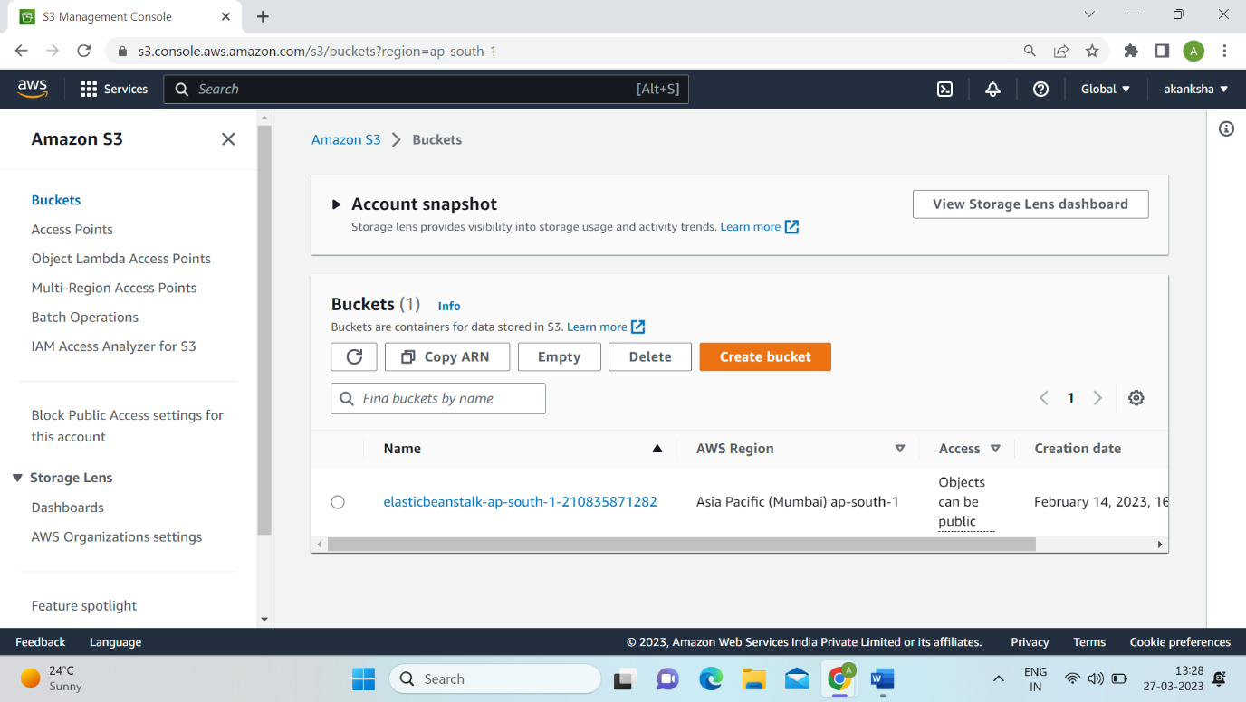

**Step 2:** Give name to your bucket and chose AWS Region.

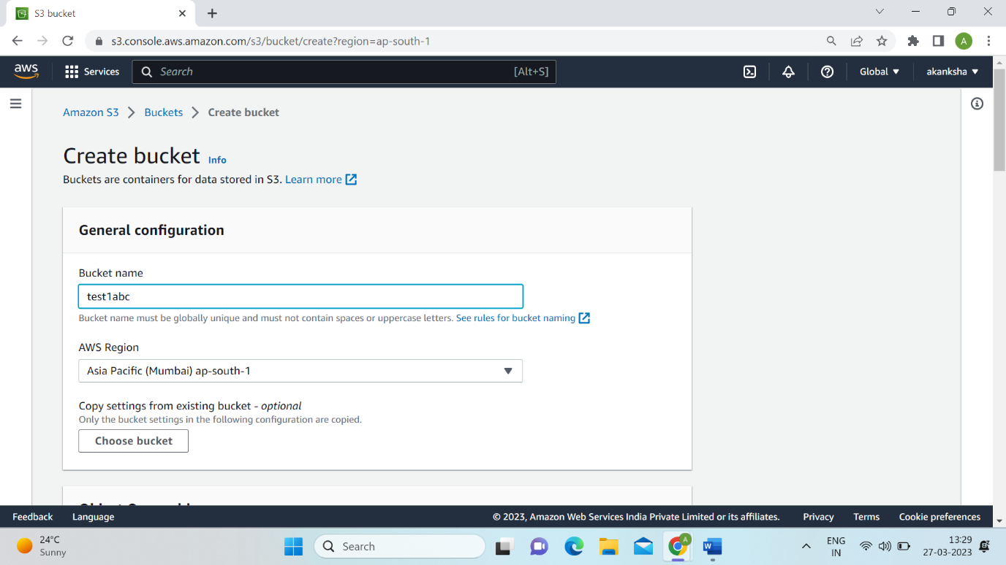

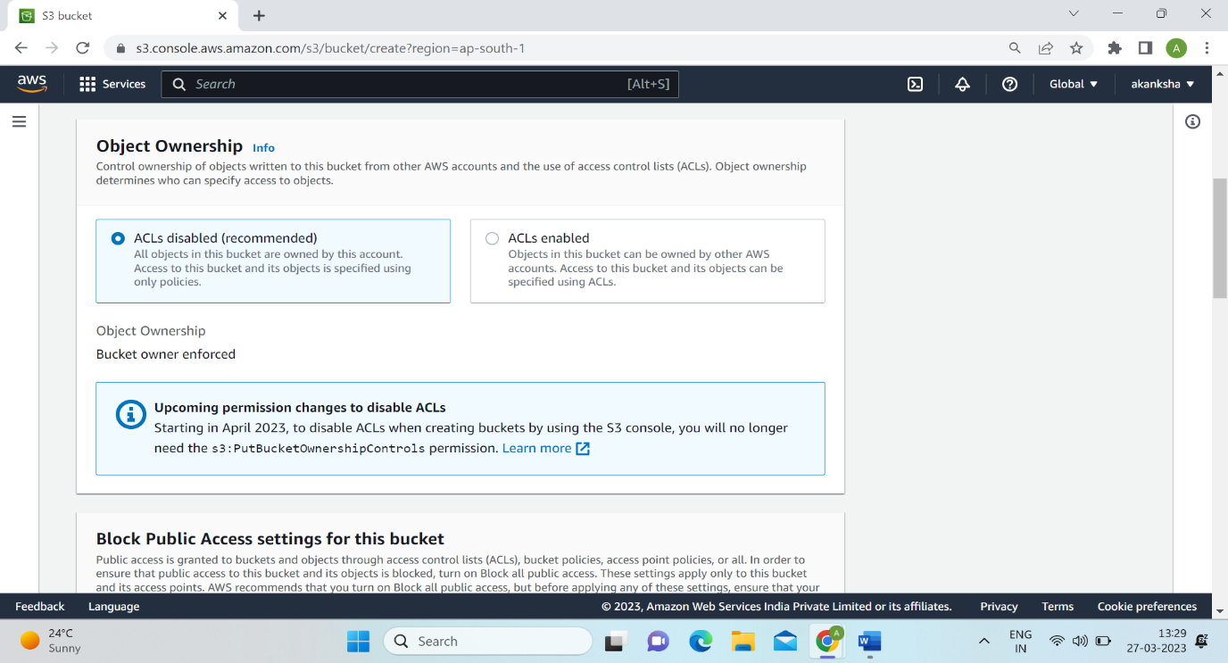

**Step 3:** Uncheck the block all public access and click on acknowledge.

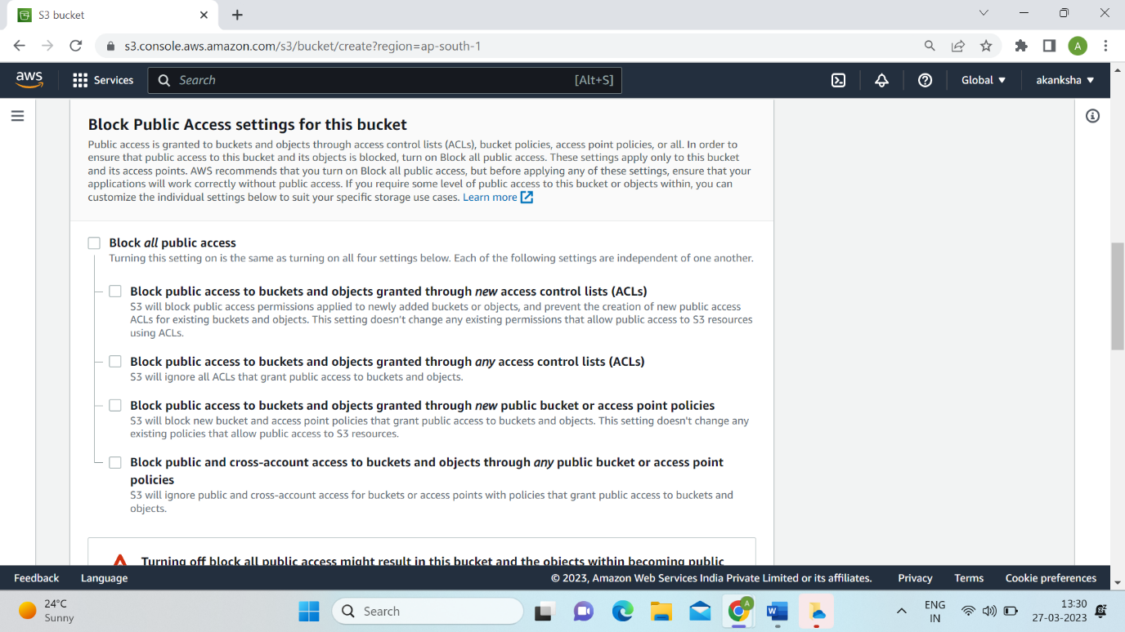

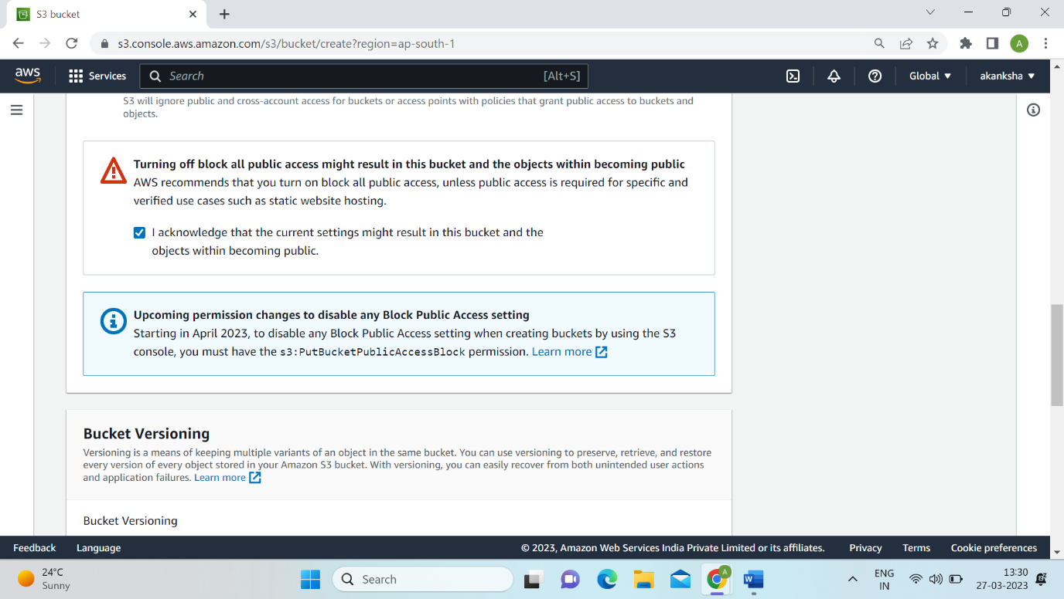

**Step 4:** Enable versioning.

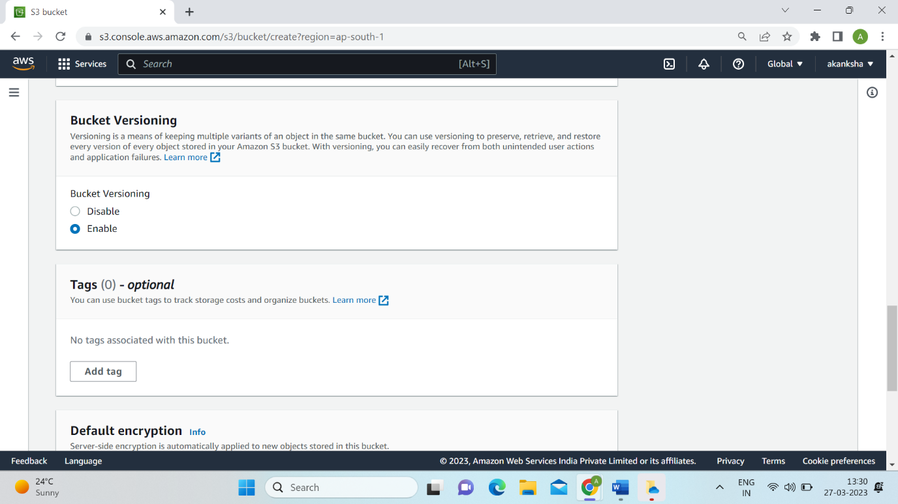

**Step 5:** Click on create bucket tab.

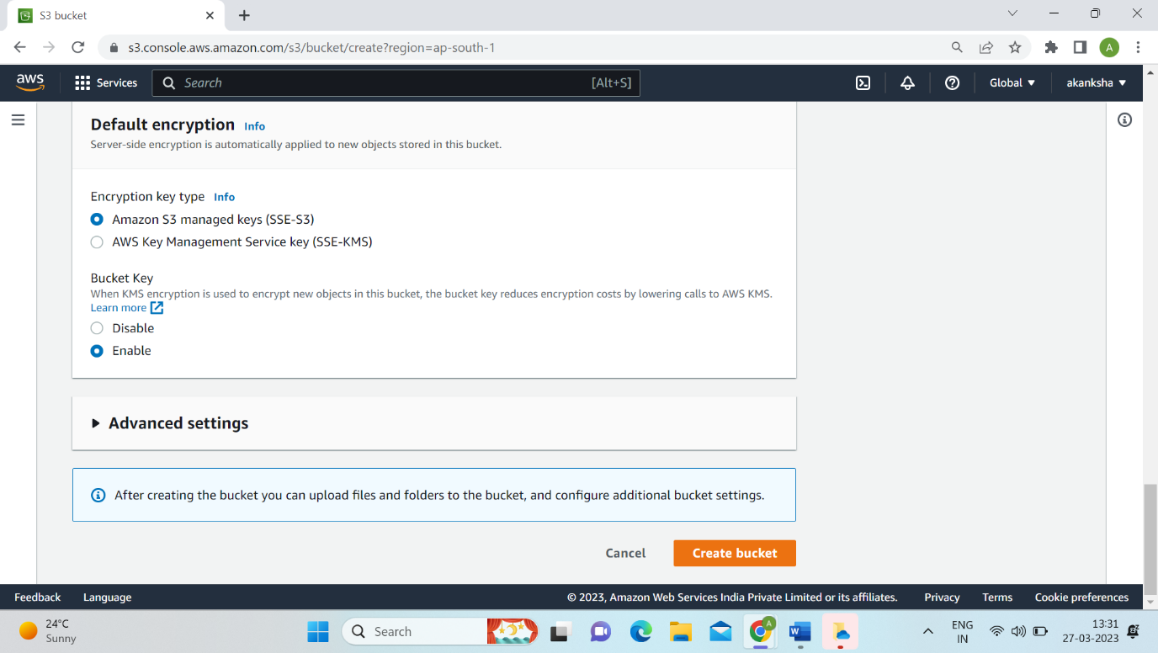

**Step 6:** Click on test1abc file to open it.

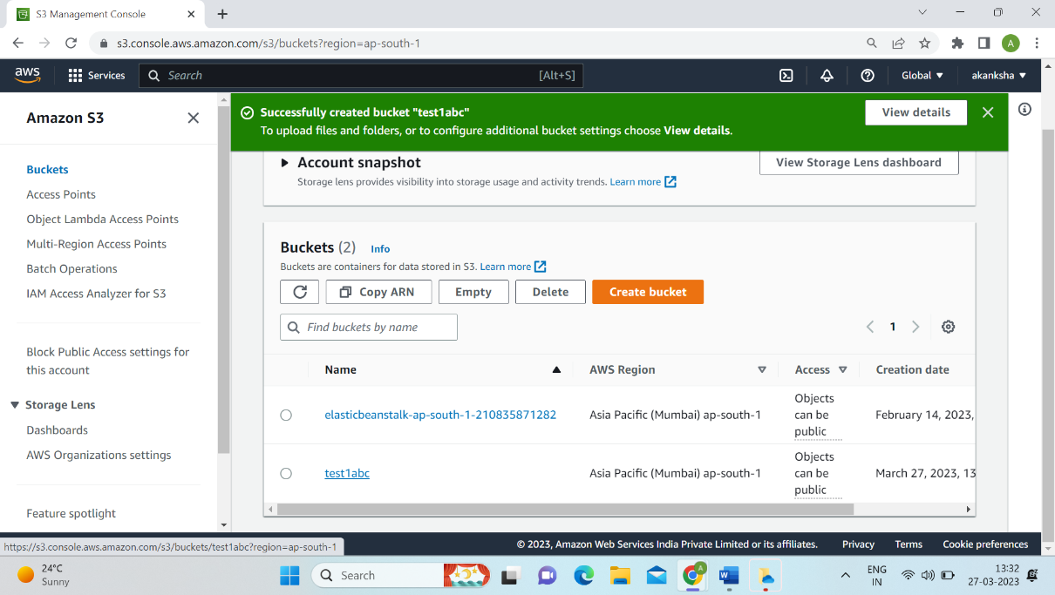

**Step 7:** Click on upload option.

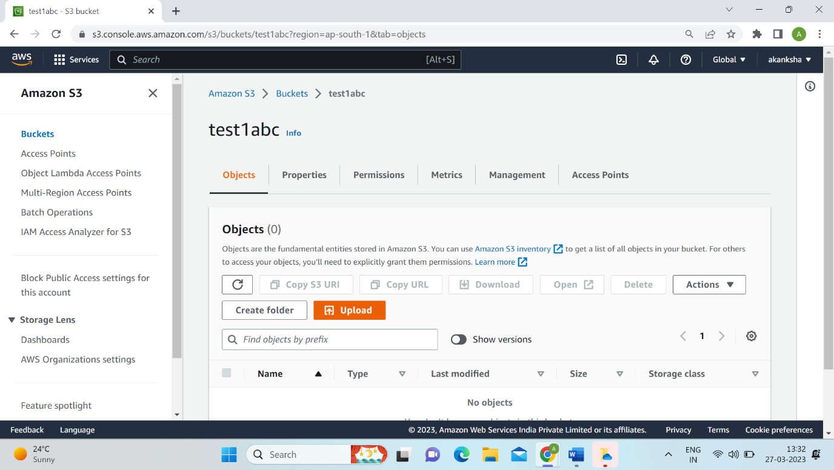

**Step 8:** Click on add file tab.

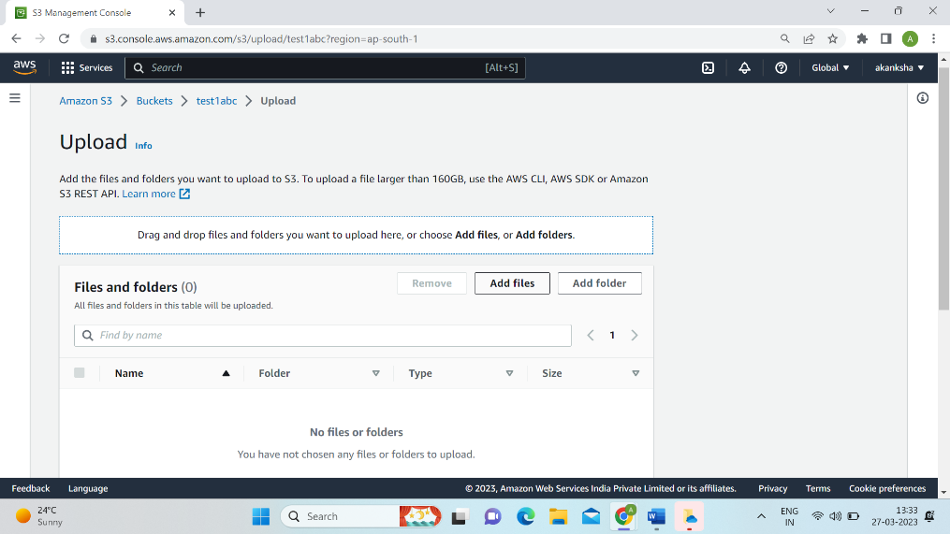

**Step 9:** Chose the file you want to upload and click on open tab.

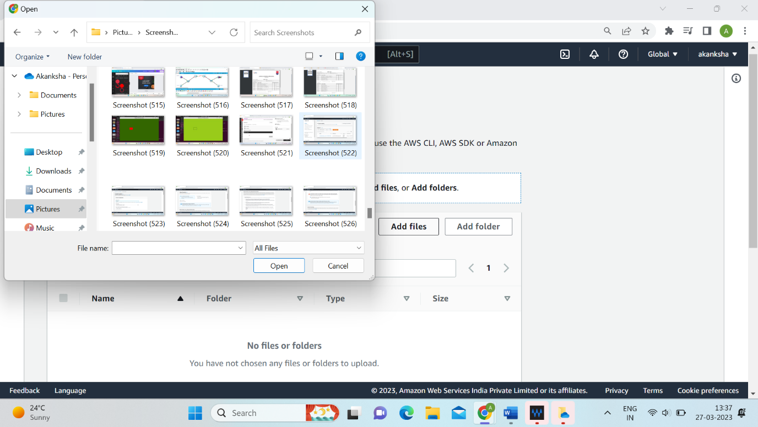

**Step 10:** Click on the upload tab.

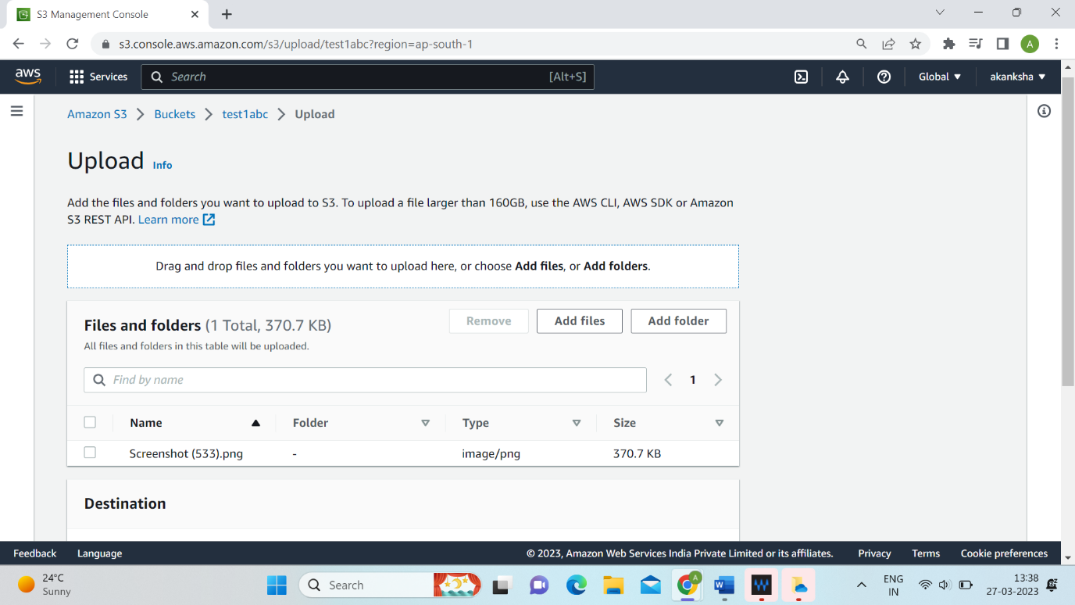

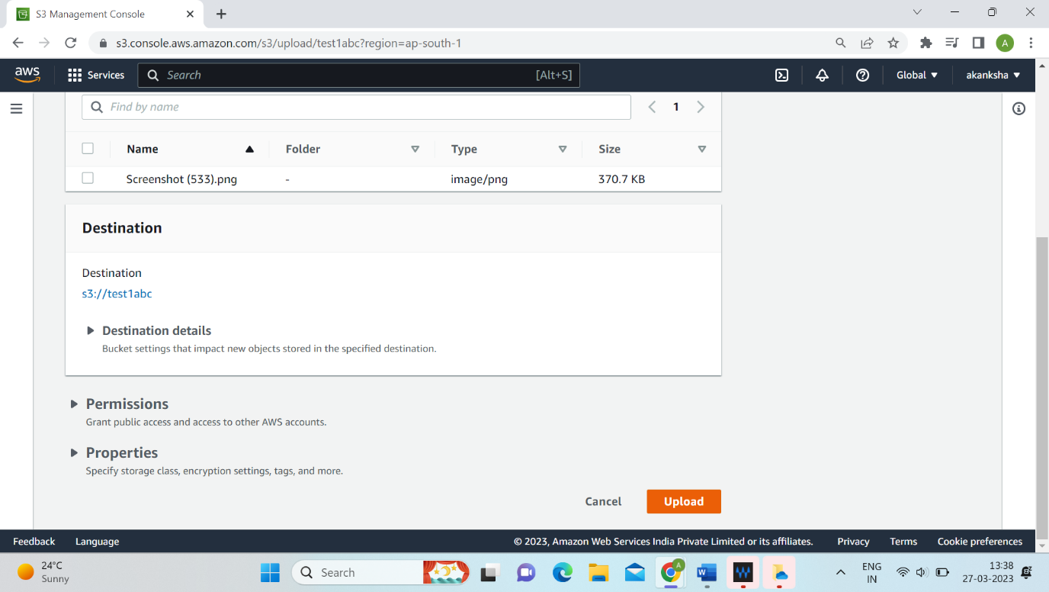

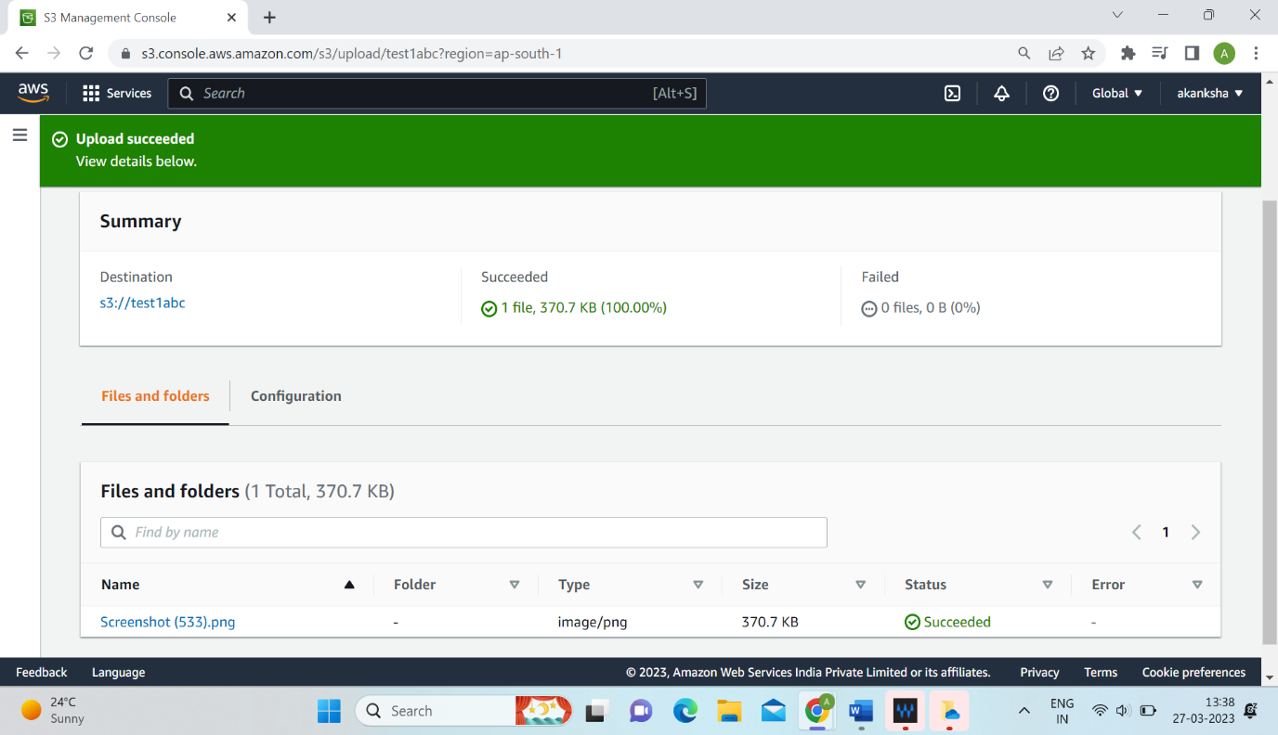

**Step 11:** To create one more bucket, click on the create bucket option.

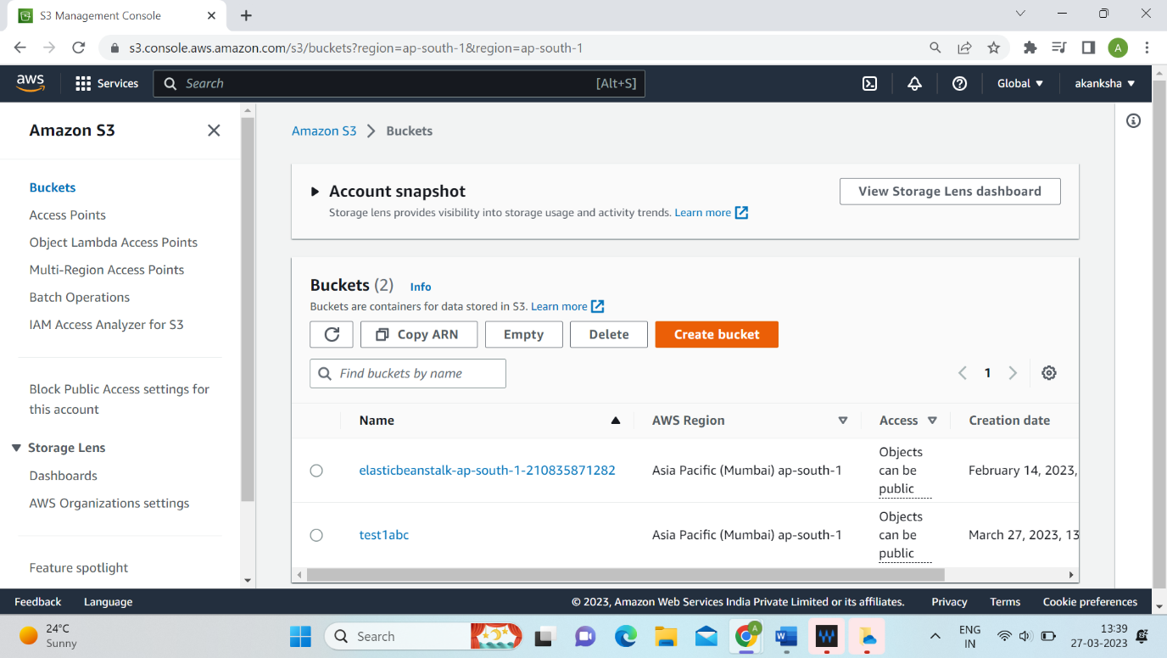

**Step 12:** Write name for the bucket “ test2abc” and chose the AWS Region.

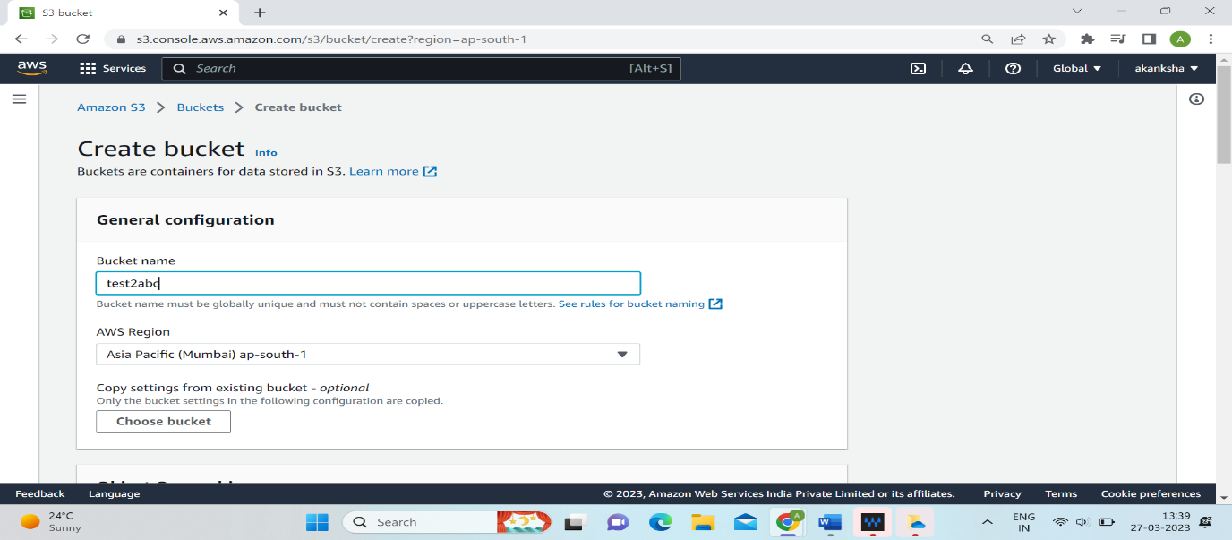

**Step 13:** Uncheck the Block all public access and click on acknowledgement. Enable Versioning.

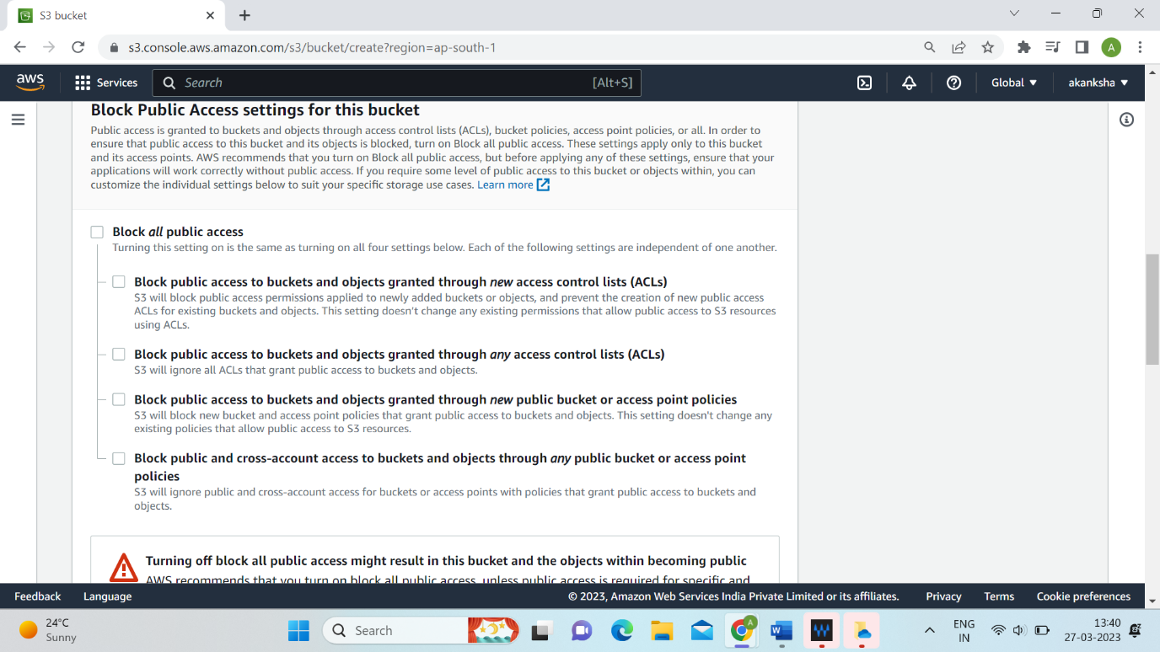

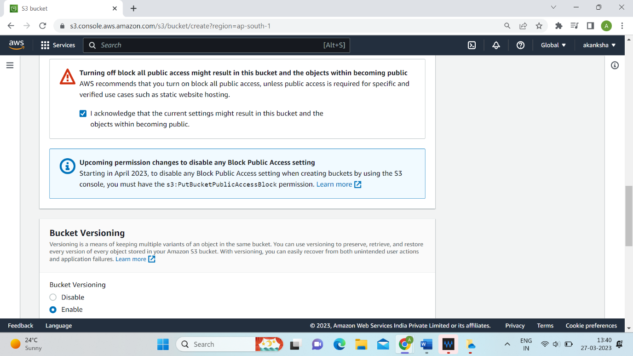

**Step 14:** Click on create bucket tab.

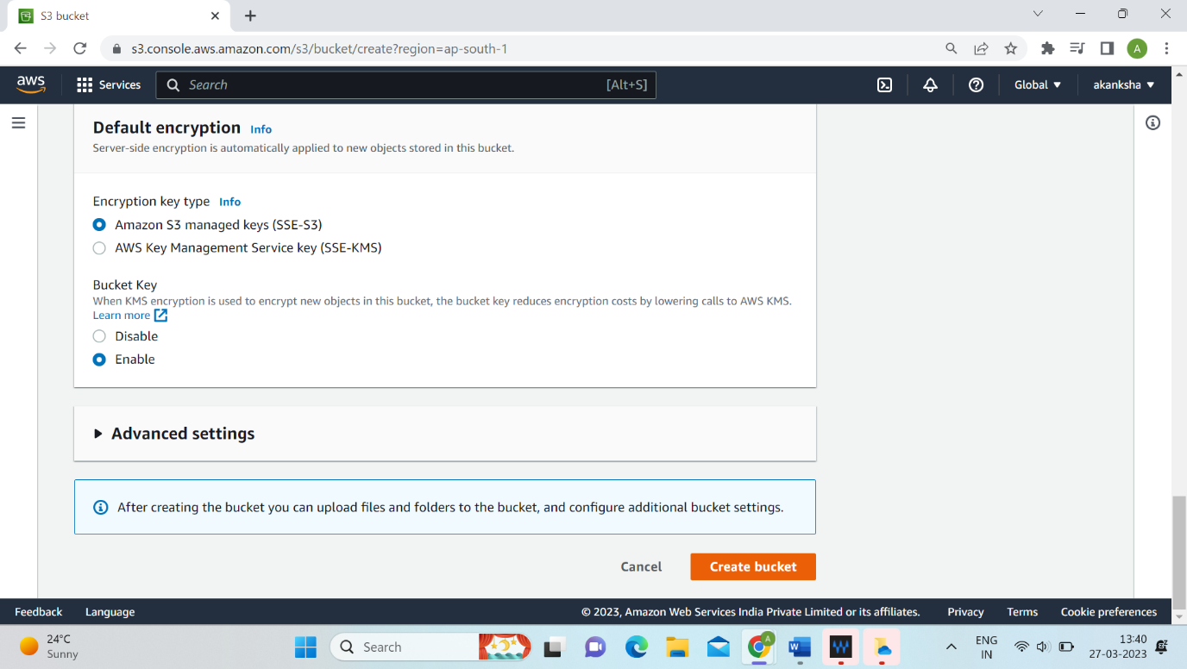

**Step 15:** Click on “test1abc”.

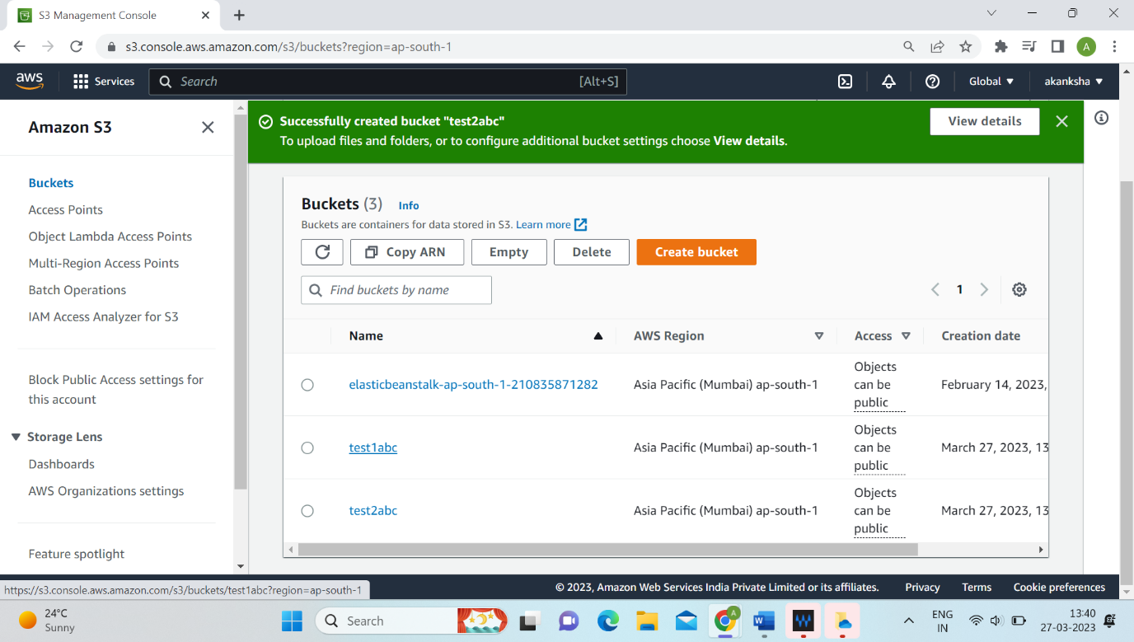

**Step 16:** Go on management.

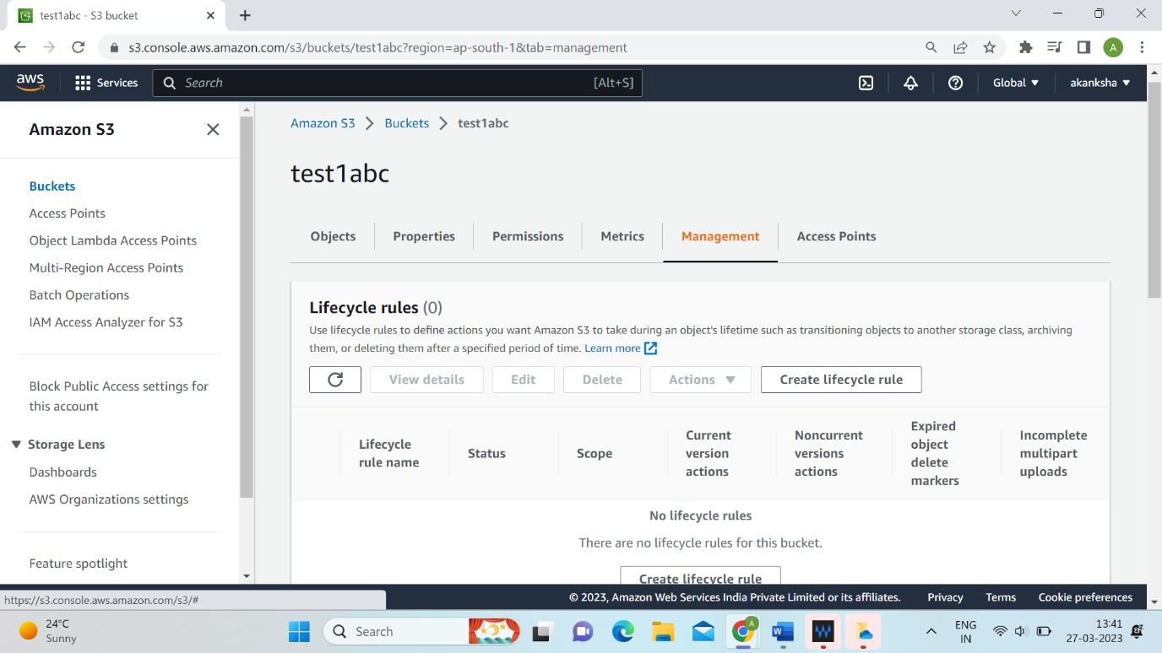

**Step 17:** Scroll down and go on replication rules. Click on create replication rule.

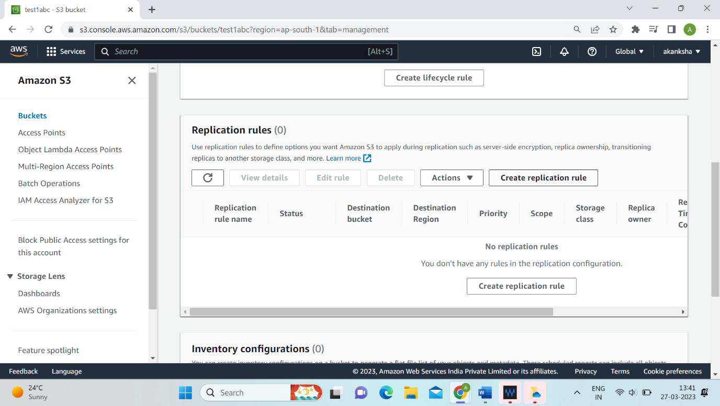

**/**

**Step 18:** Give the replication rule name.

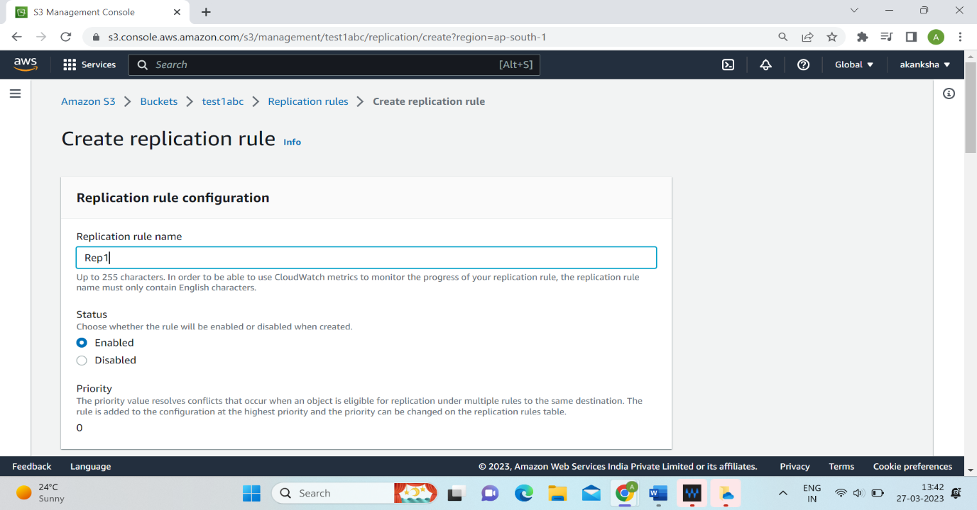

**Step 19:** Select ‘Apply to all objects in the bucket’ option in rule scope.

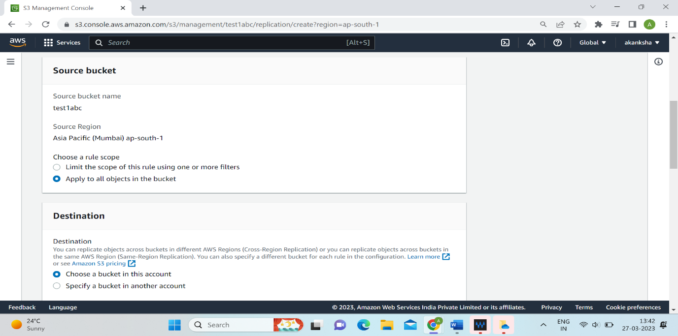

**Step 20:** Browse the S3 destination bucket ‘test2abc’.

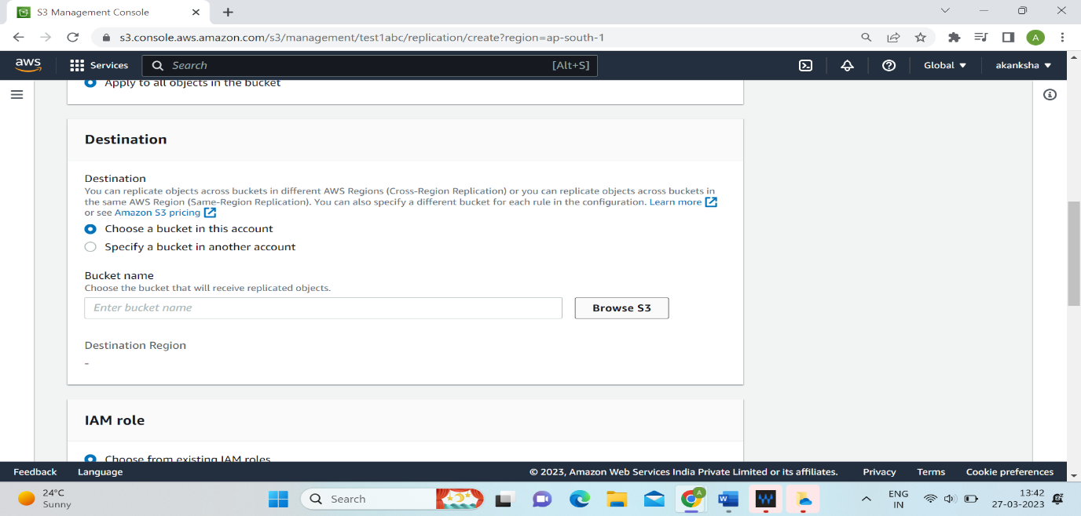

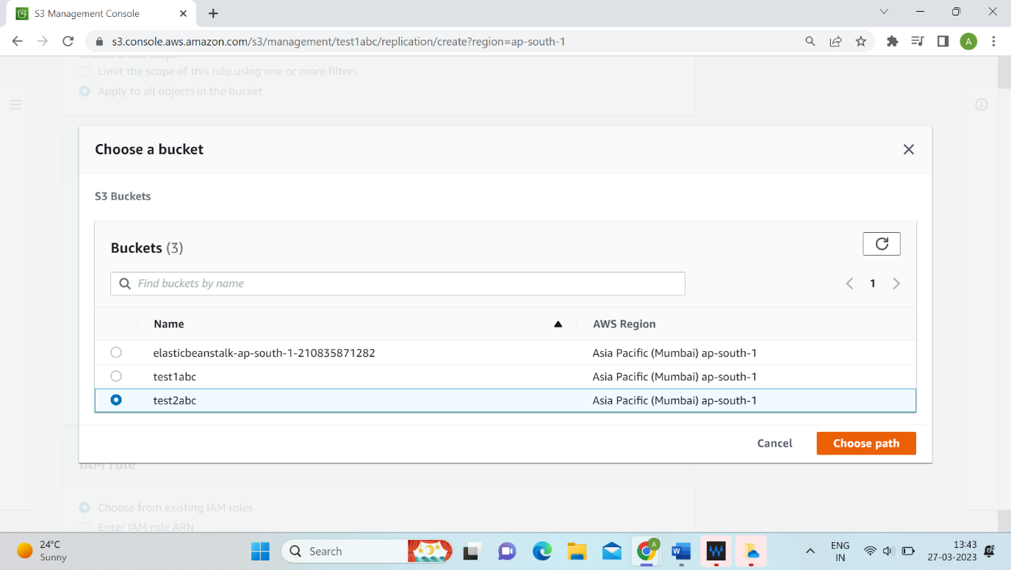

**Step 21:** Select IAM role.

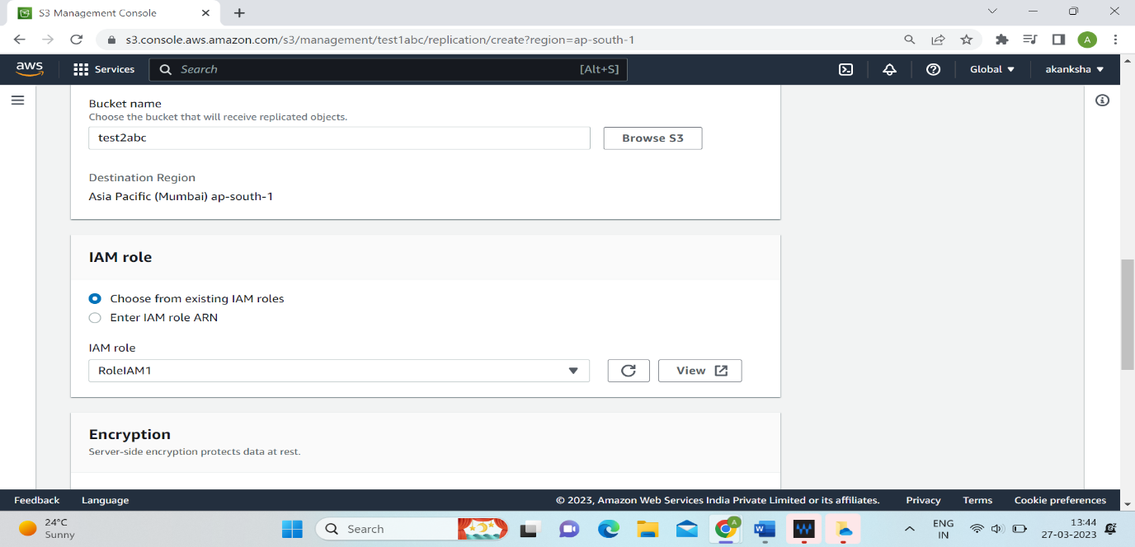

**Step 22:** Click on Save tab.

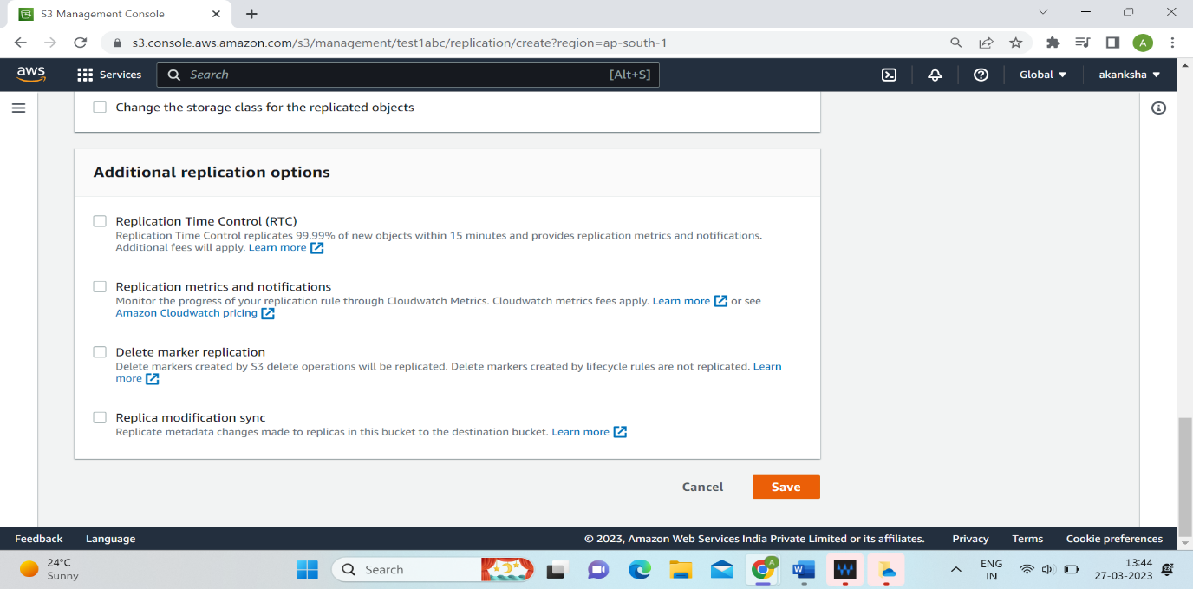

**Step 23:** Select ‘Yes, replicate existing objects’ option and click on submit tab.

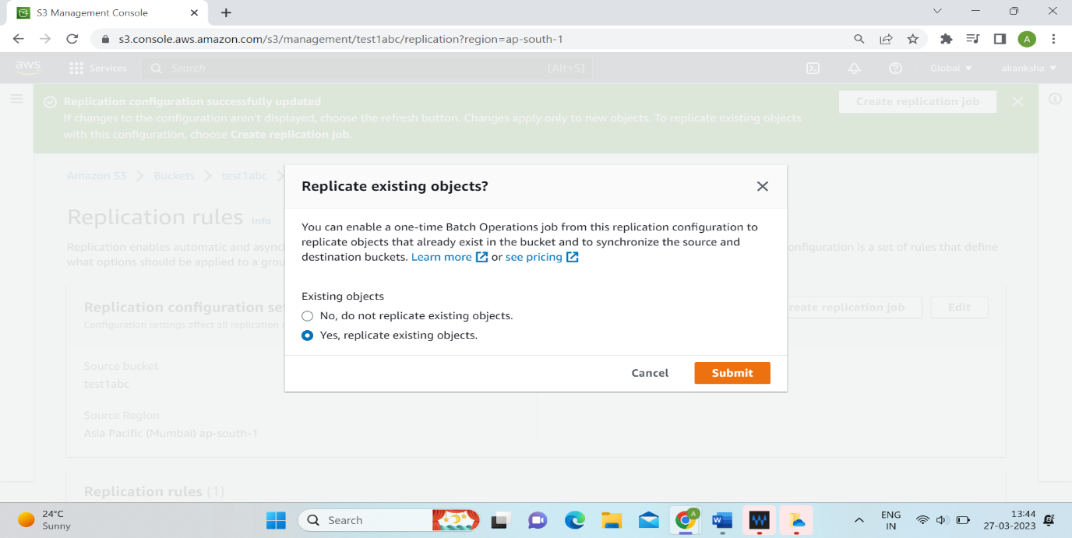

**Step 24:** Select ‘Automatically run the job when it’s ready’ option.

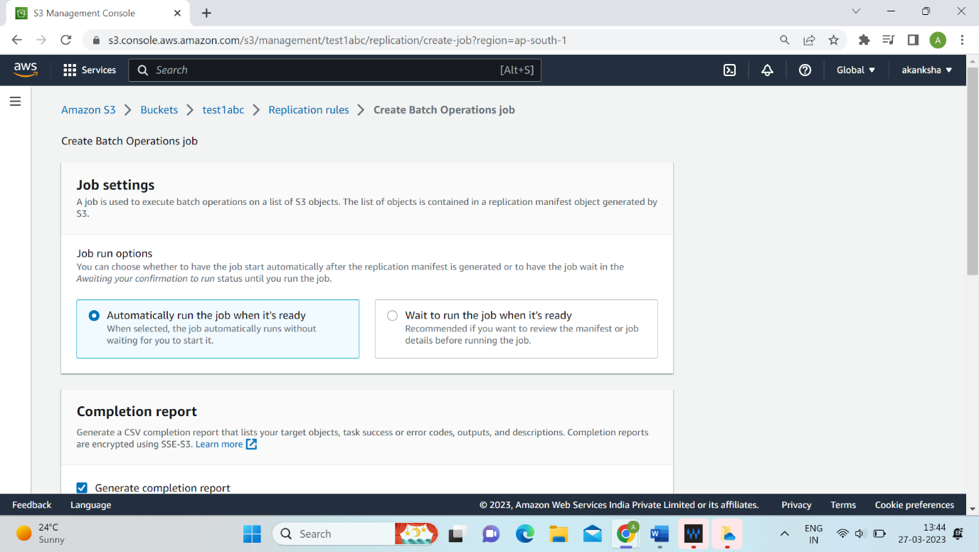

**Step 25:** Browse the report destination ‘test2abc’ and click on chose path tab.

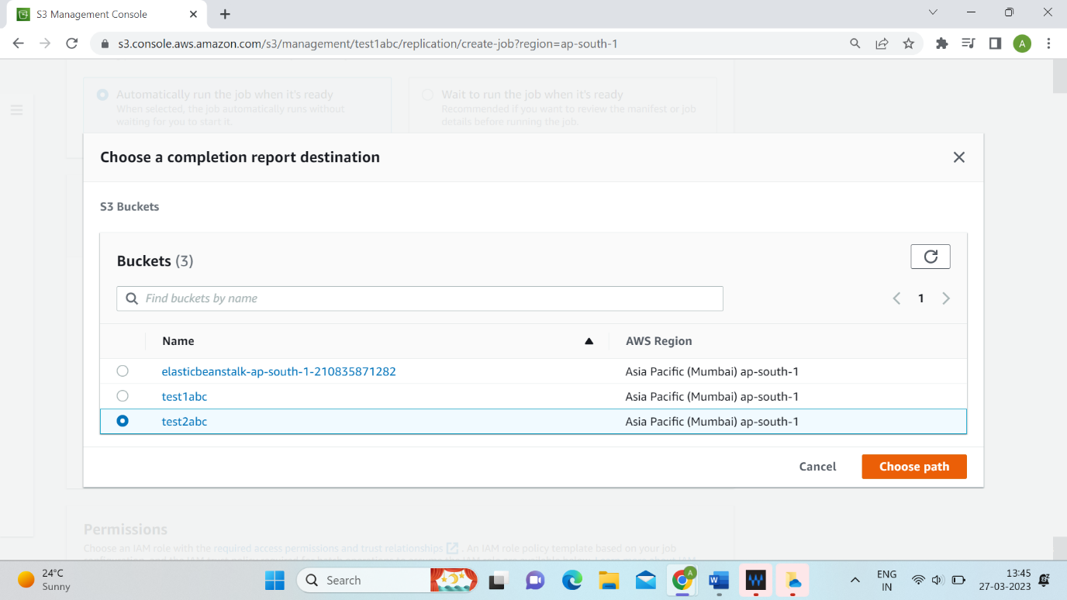

**Step 26:** Click on Save tab.

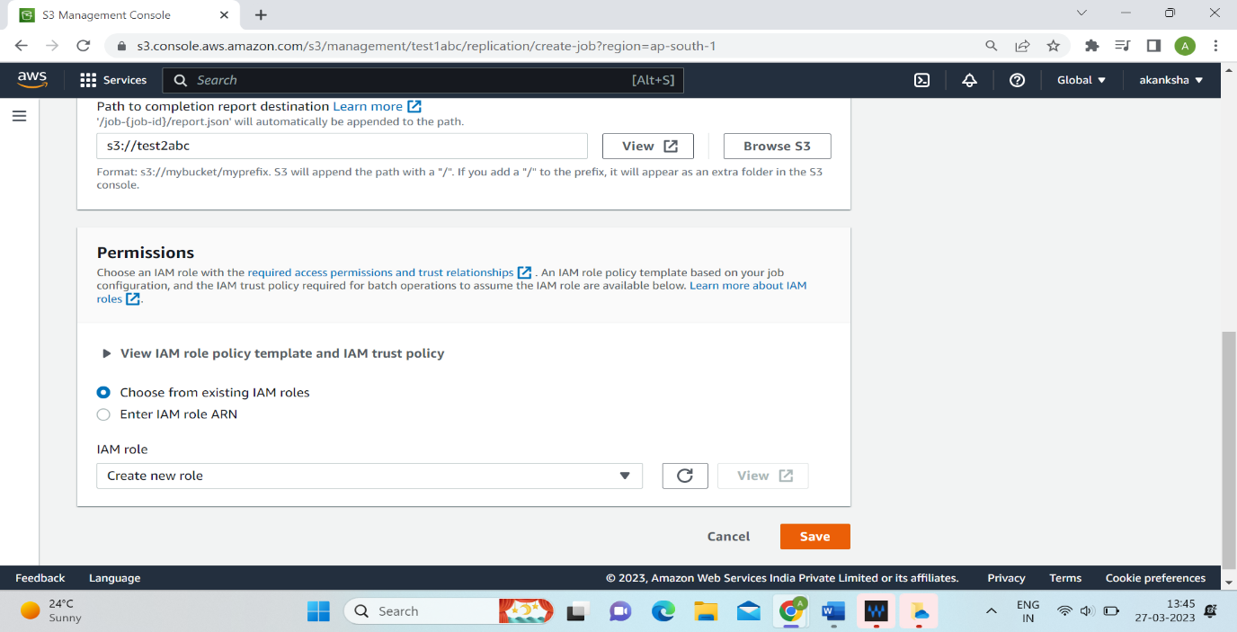

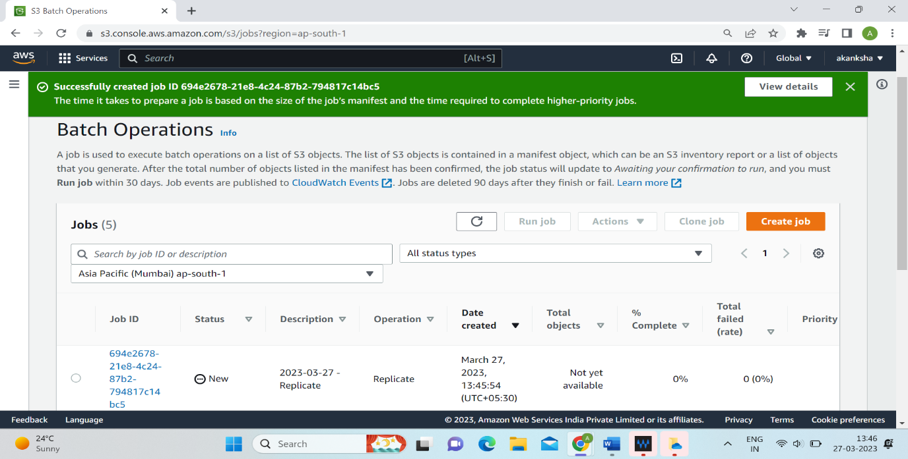

**Step 27:** Click on ‘test2abc’. You will see object has been replicated.

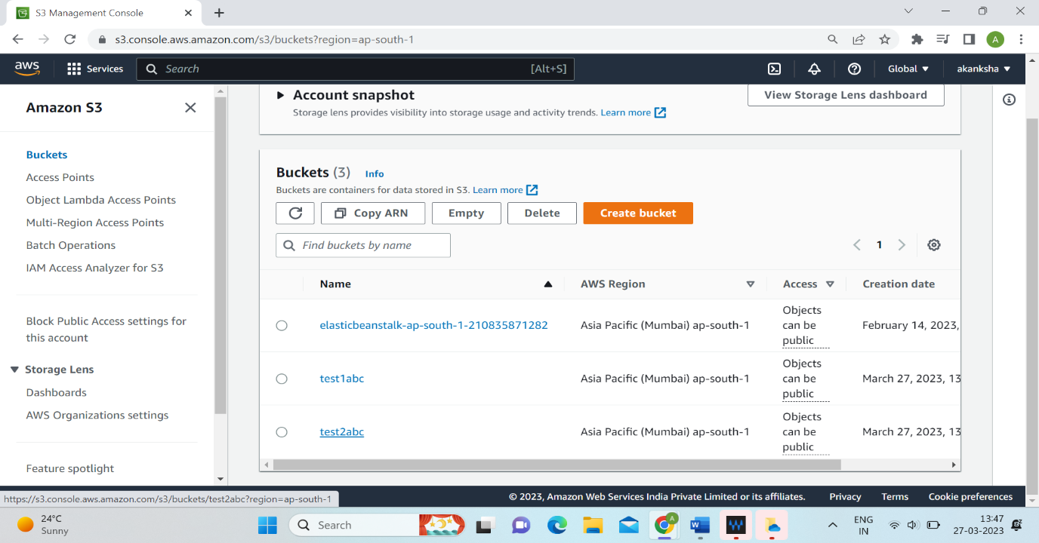

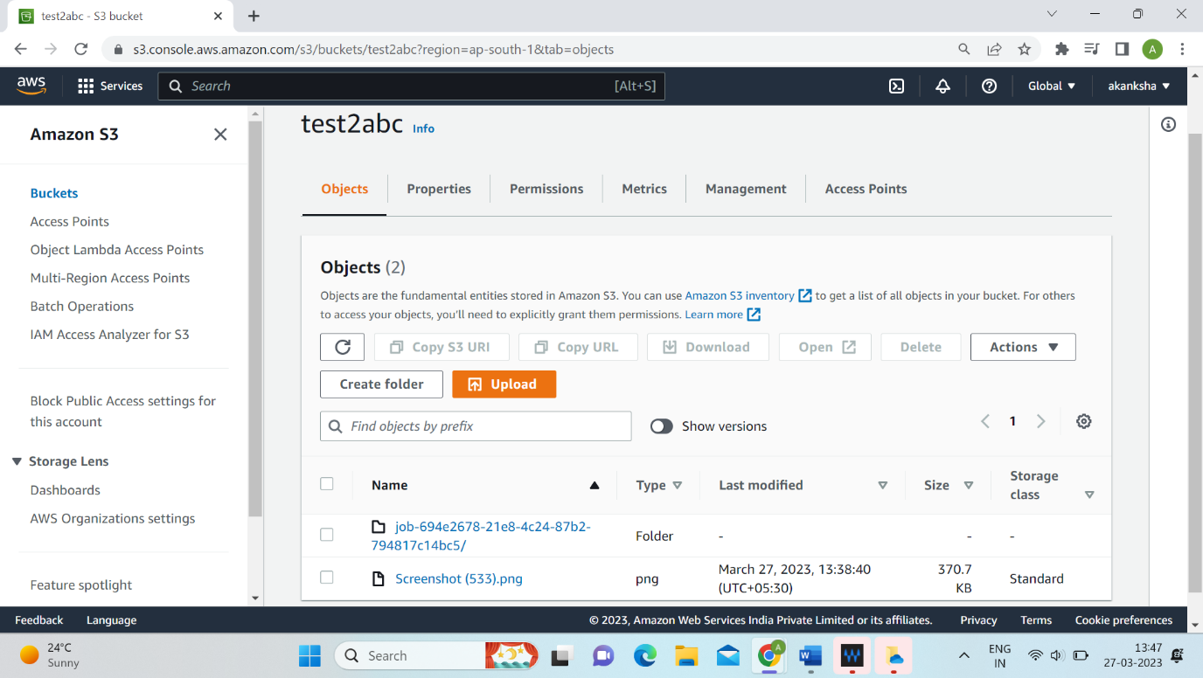

**Step 28:** Click on create bucket tab.

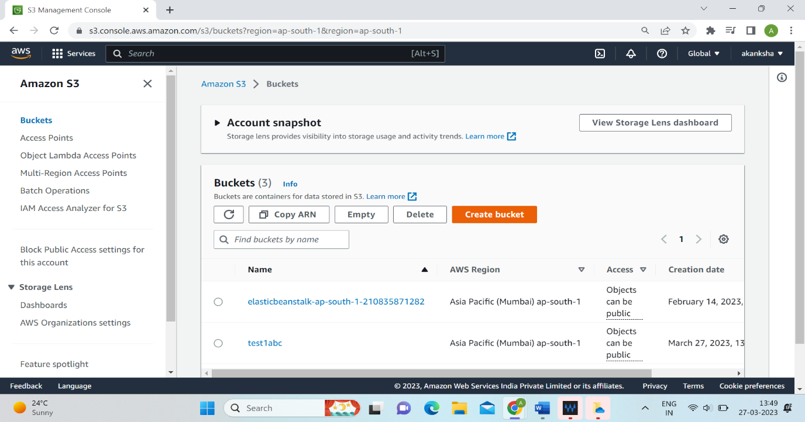

**Step 29:** Give name to your S3 bucket and select the AWS Region other than the region of test1abc.

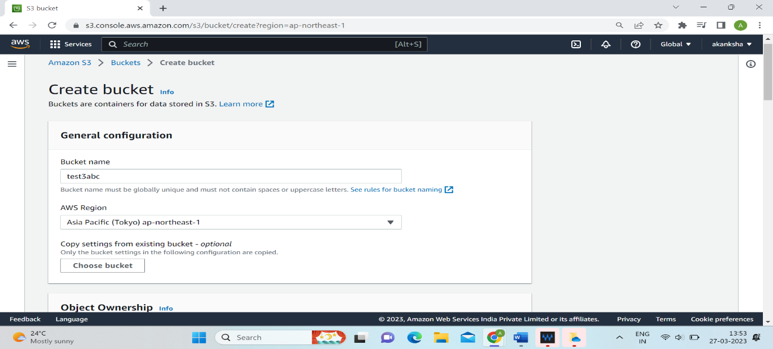

**Step 30:** Uncheck the block all public access.

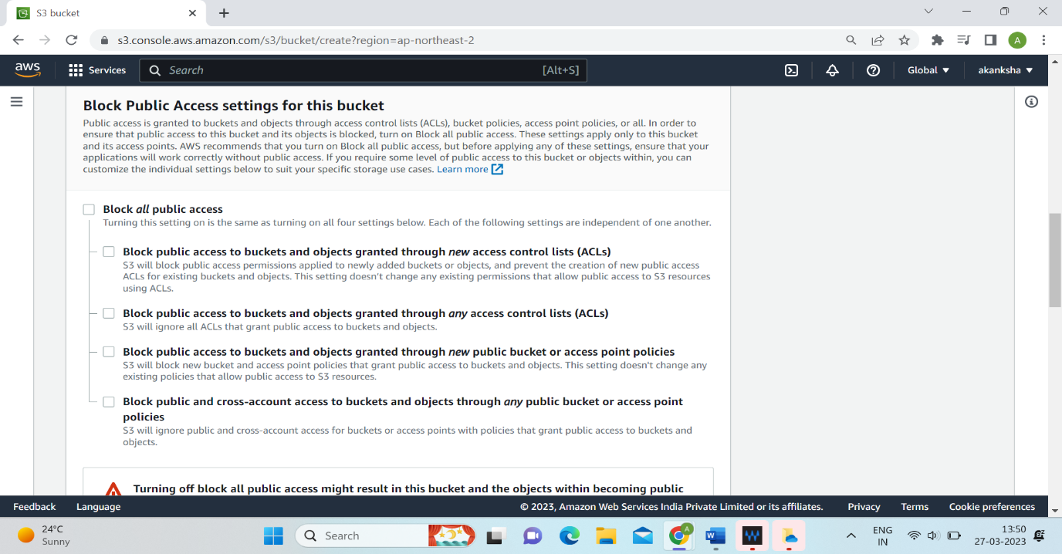

**Step 31:** Click on acknowledge option and check enable option.

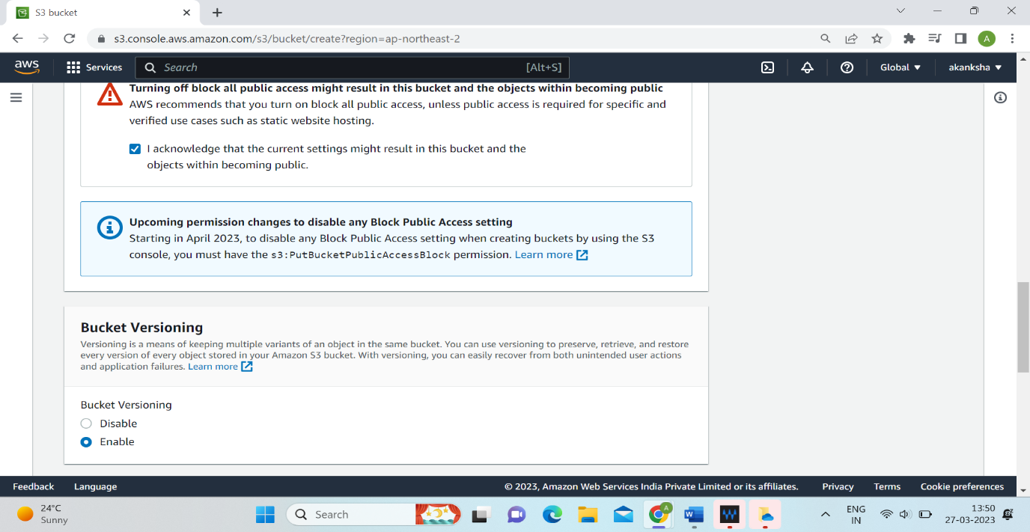

**Step 32:** Click on create bucket tab.

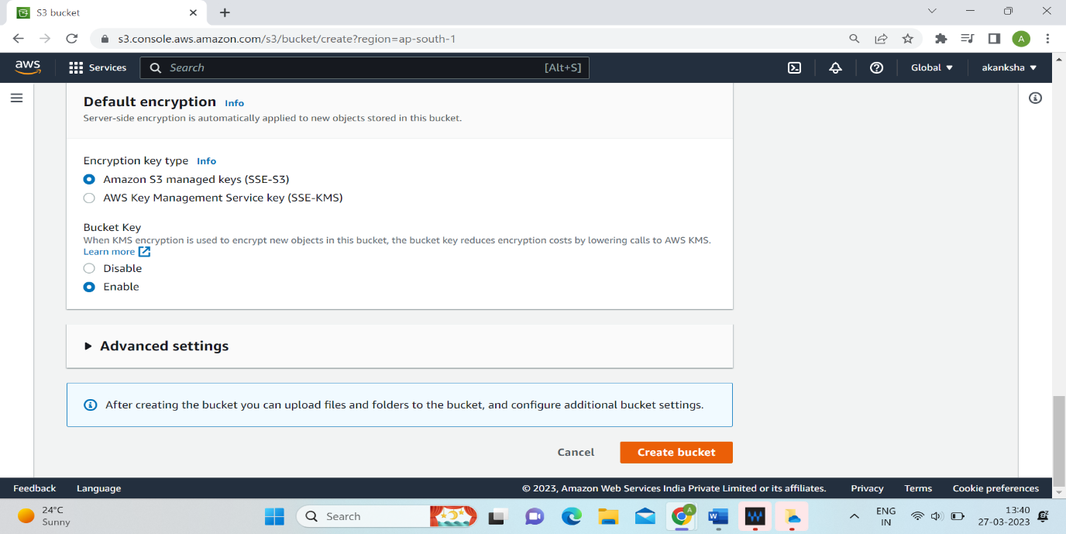

**Step 33:** Select test1abc bucket.

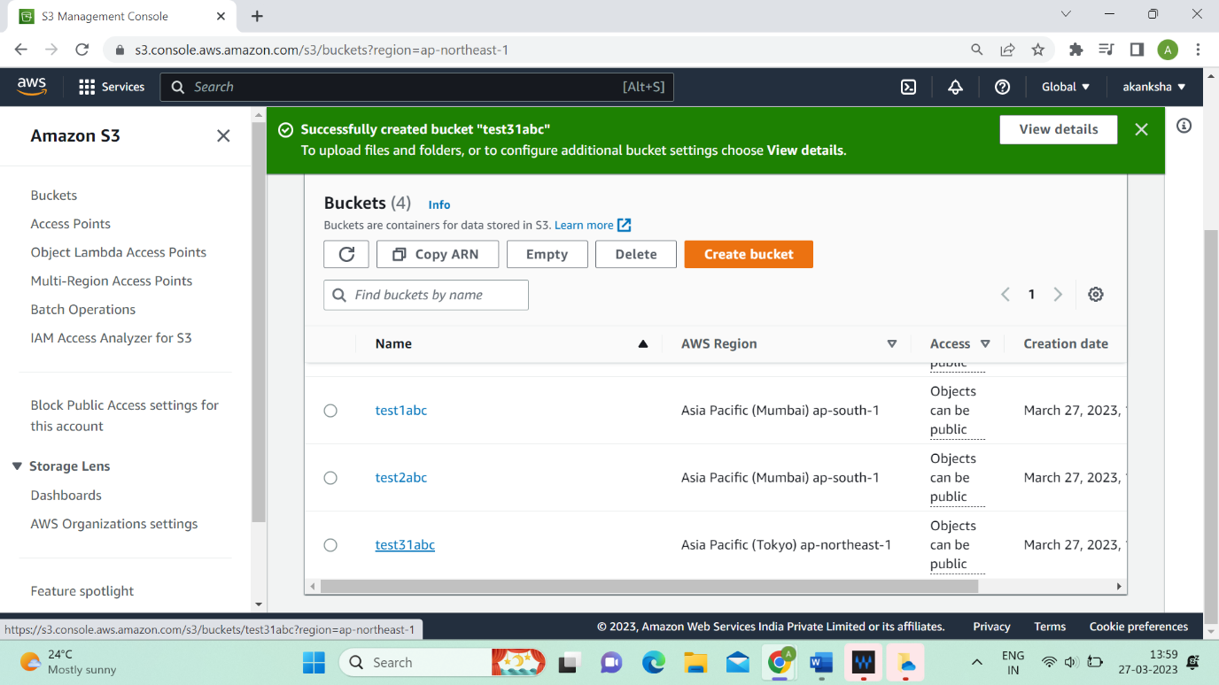

**Step 34:** Go on management and scroll down at replication rules. Click on create replication rules.

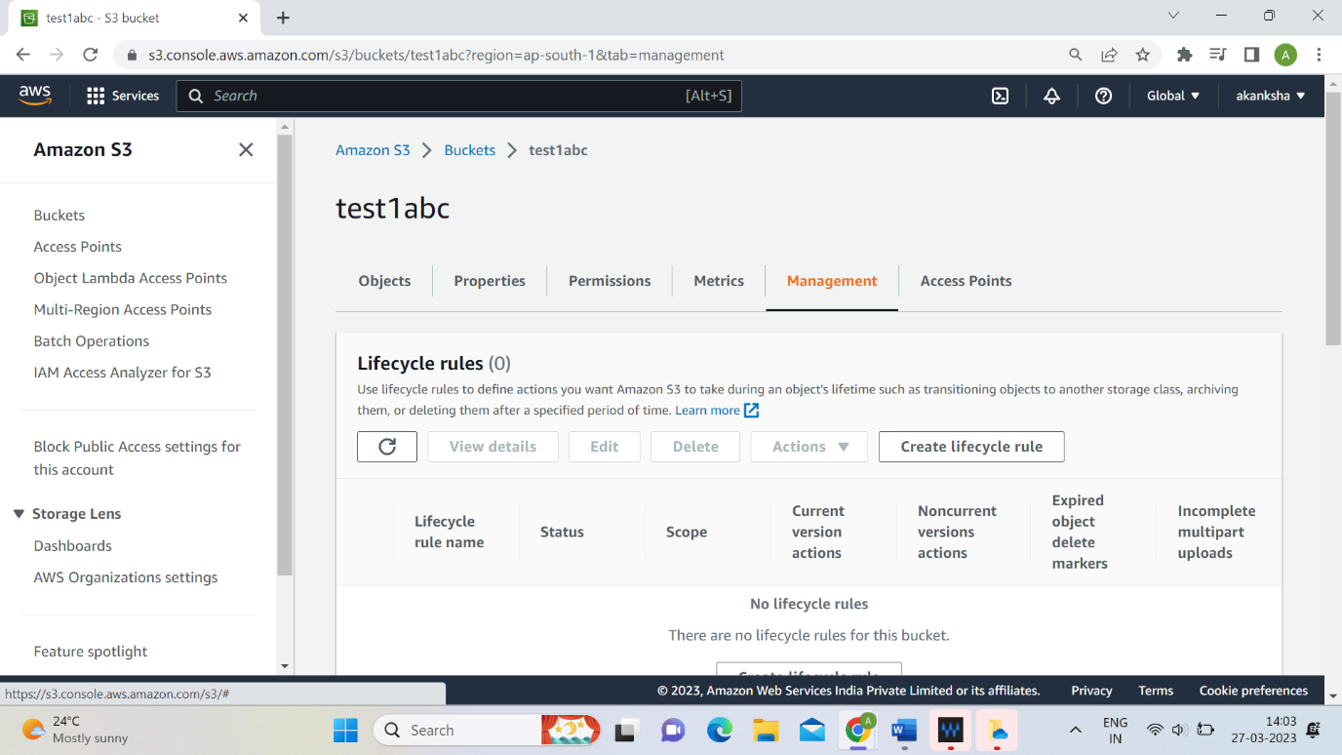

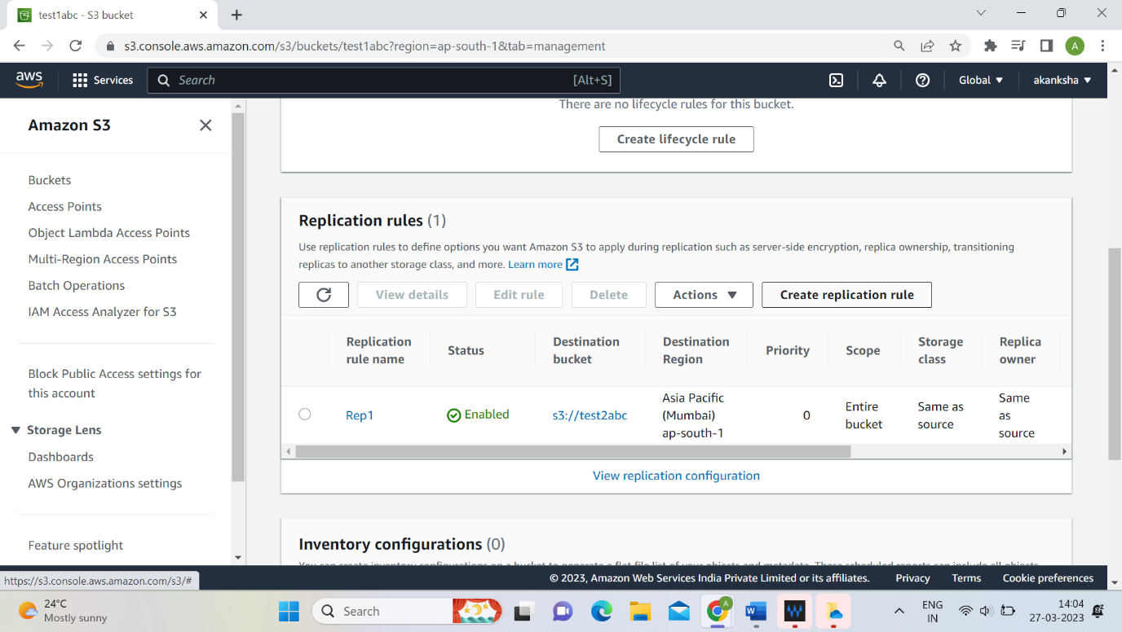

**Step 35:** Give name to rule.

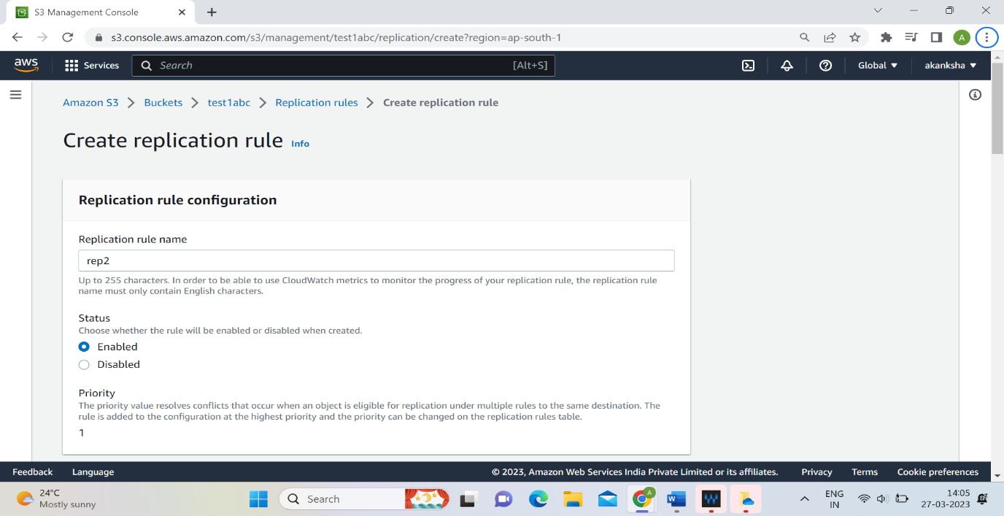

**Step 36:** Select Apply to all object in the bucket option.

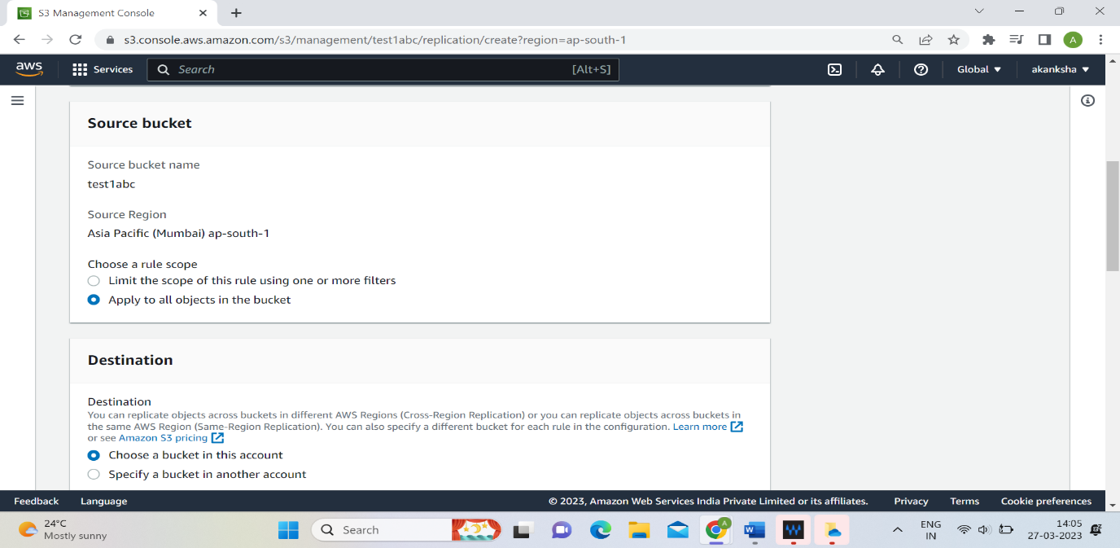

**Step 37:** Browse the destination bucket and click on chose path.

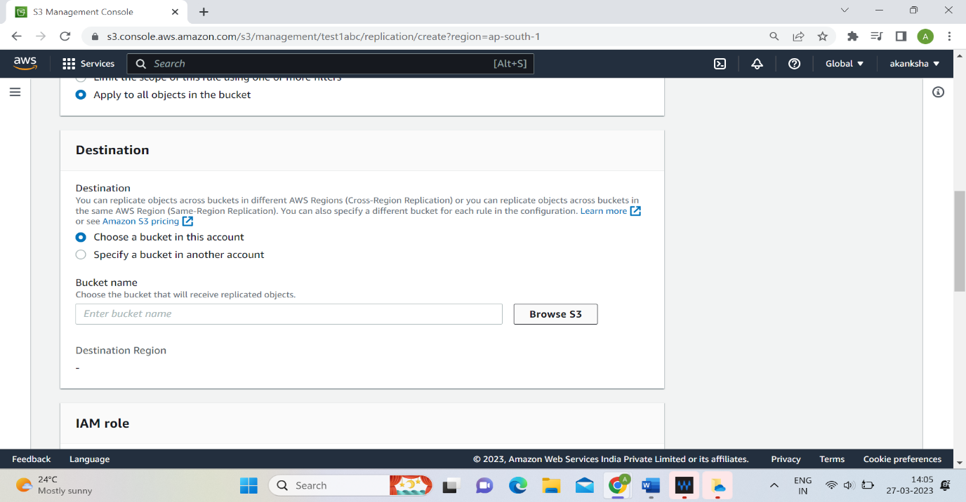

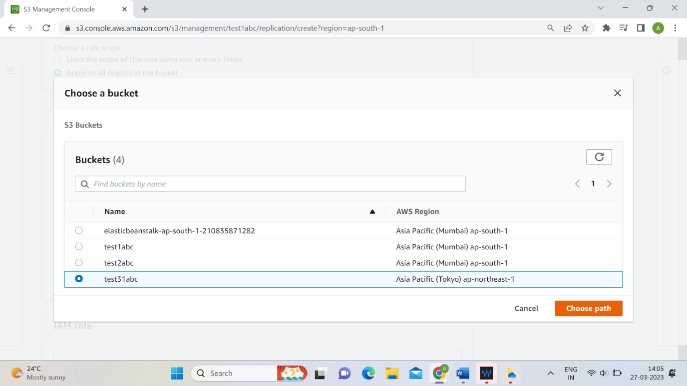

**Step 38:** Click on Save tab.

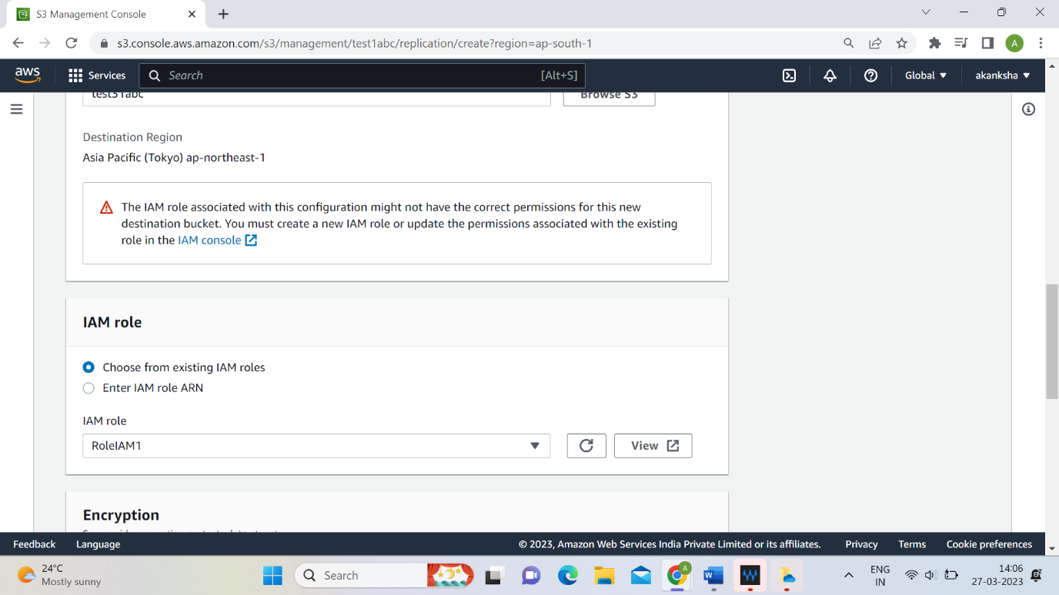

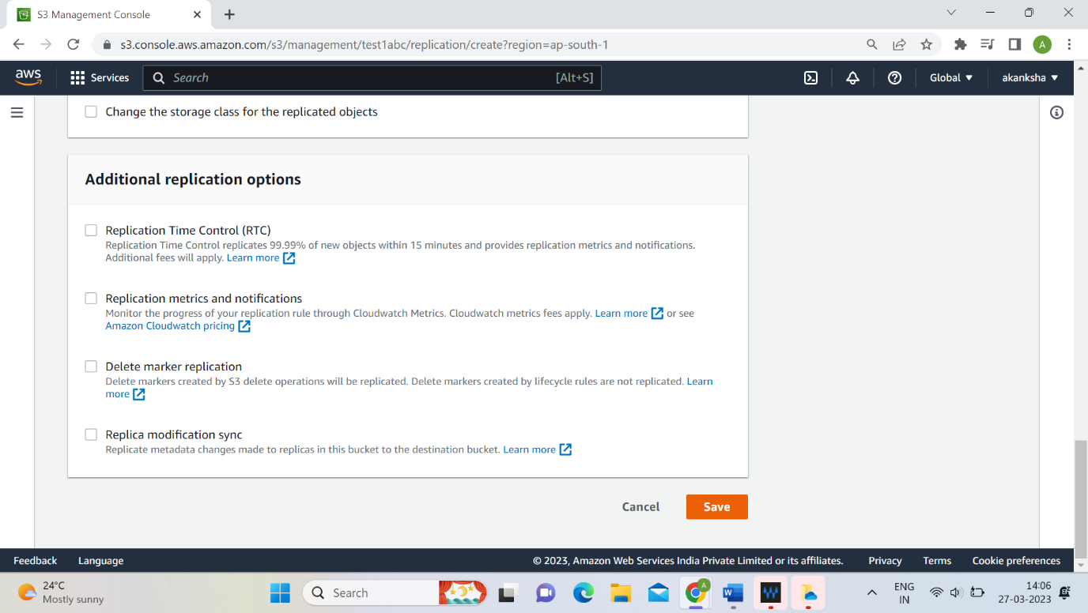

**Step 39:** Select Yes option and click on submit option.

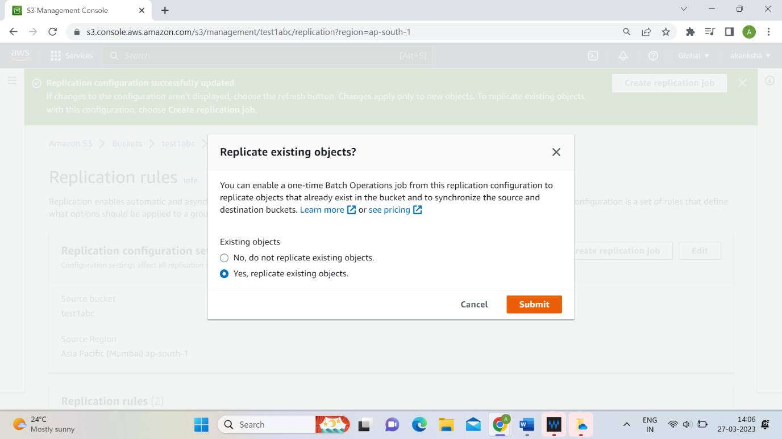

**Step 40:** Select Automatically run the job when it’s ready.

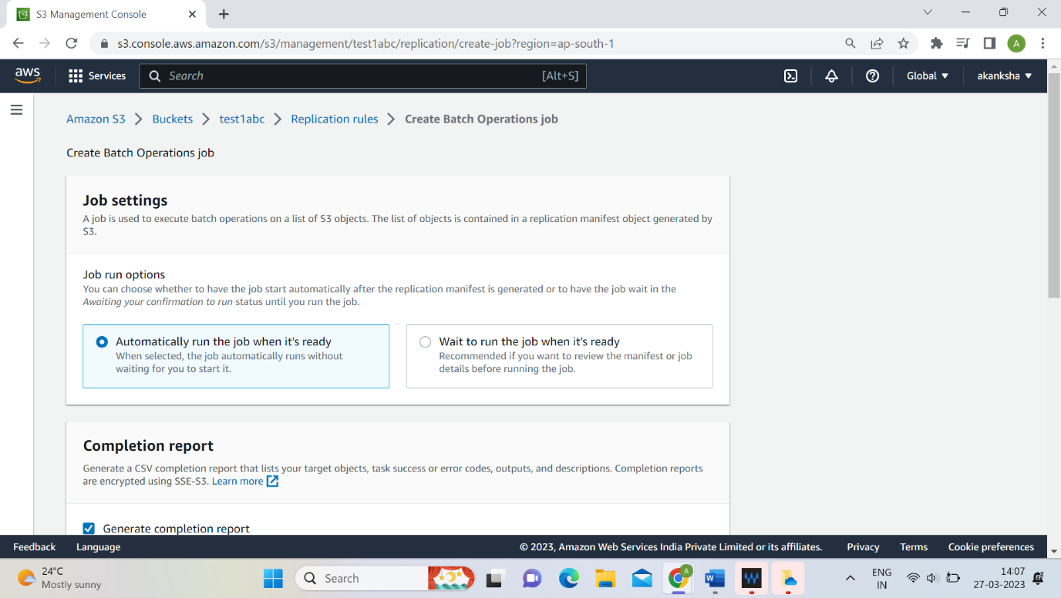

**Step 41:** Select test31abc bucket and click on choose path.

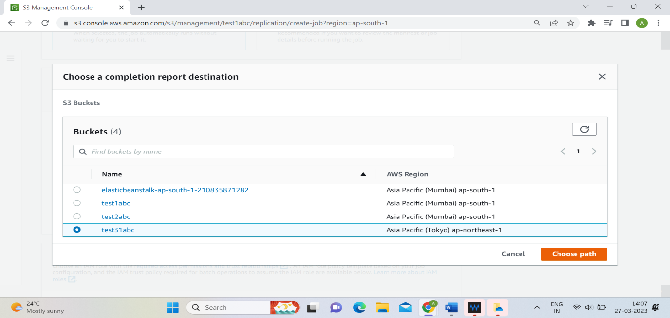

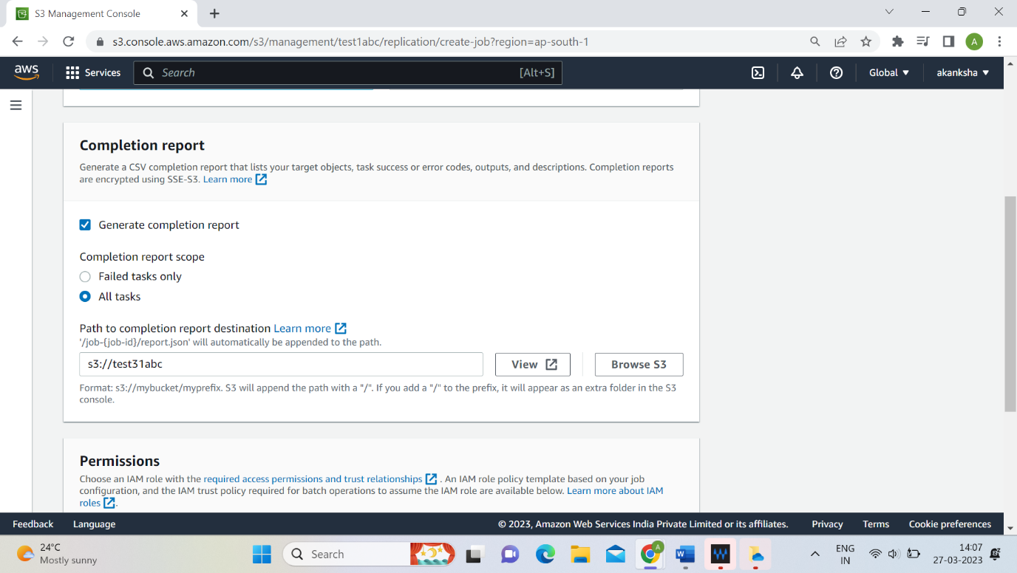

**Step 42:** Click on save tab.

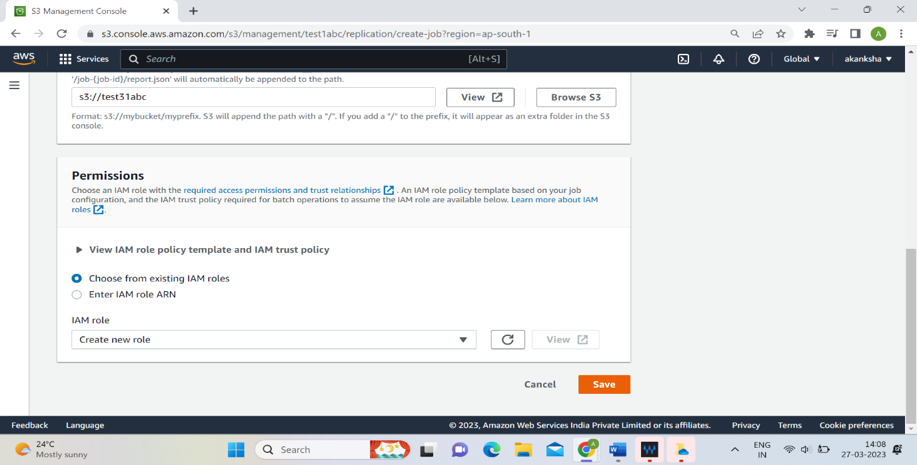

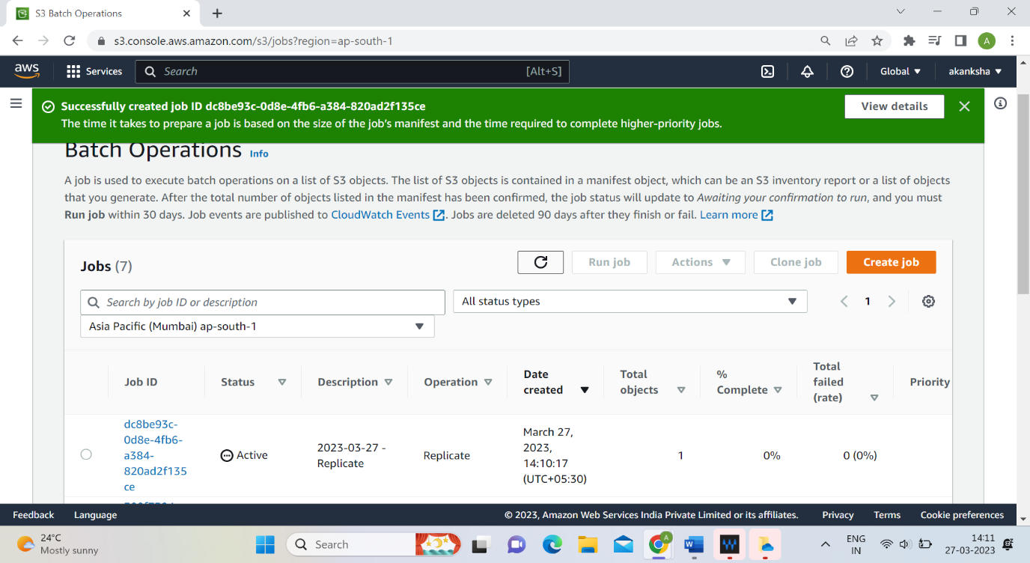

You will see rule been replicated.

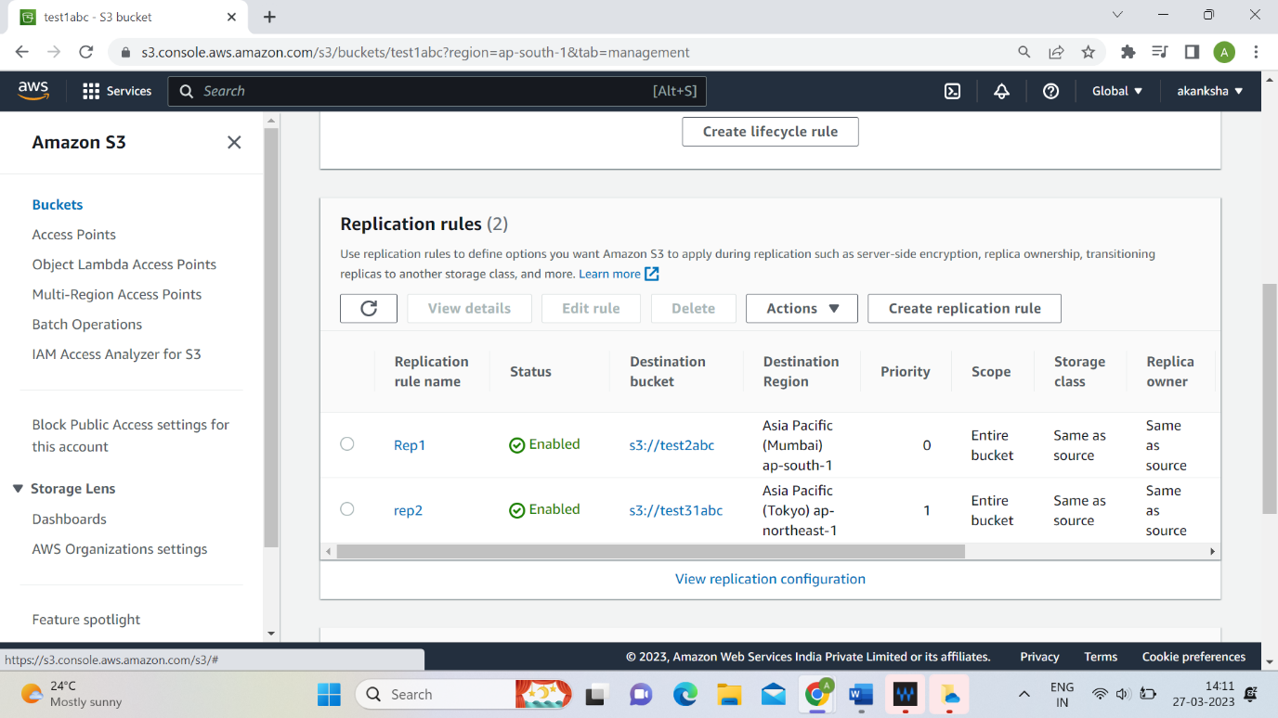

**Step 43:** Go to bucket option and click on ‘test1abc’.

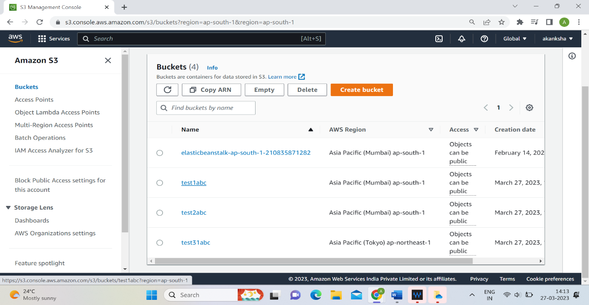

**Step 44:** Go on management and click on create lifecycle rule.

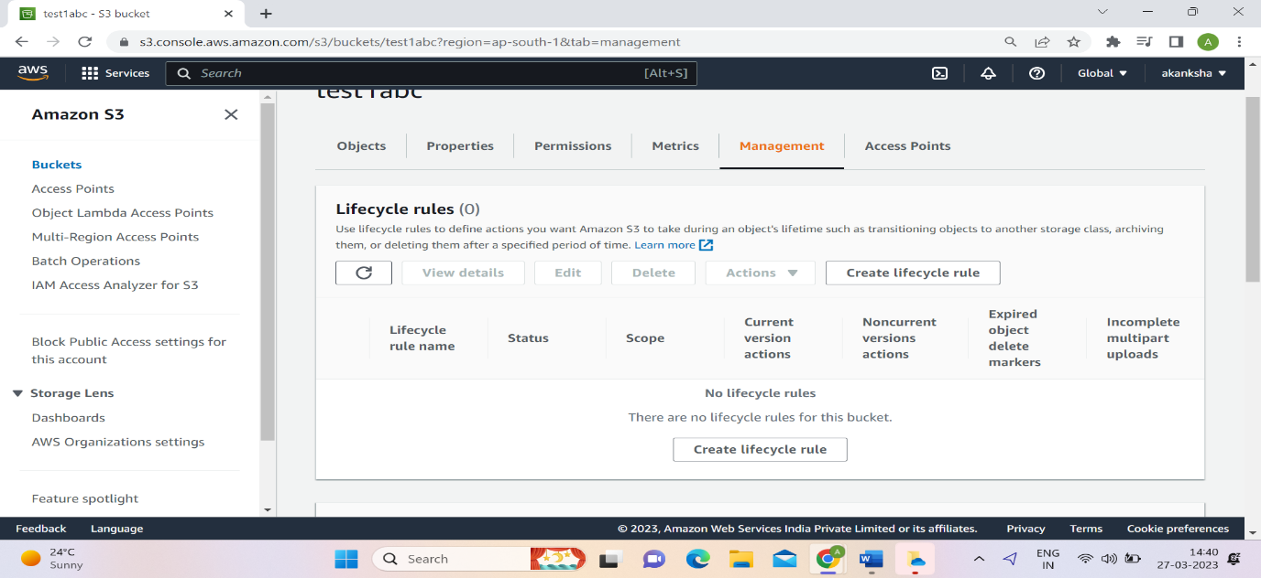

**Step 45:** Give name to the lifecycle rule. Click on apply to all object option and acknowledge it.

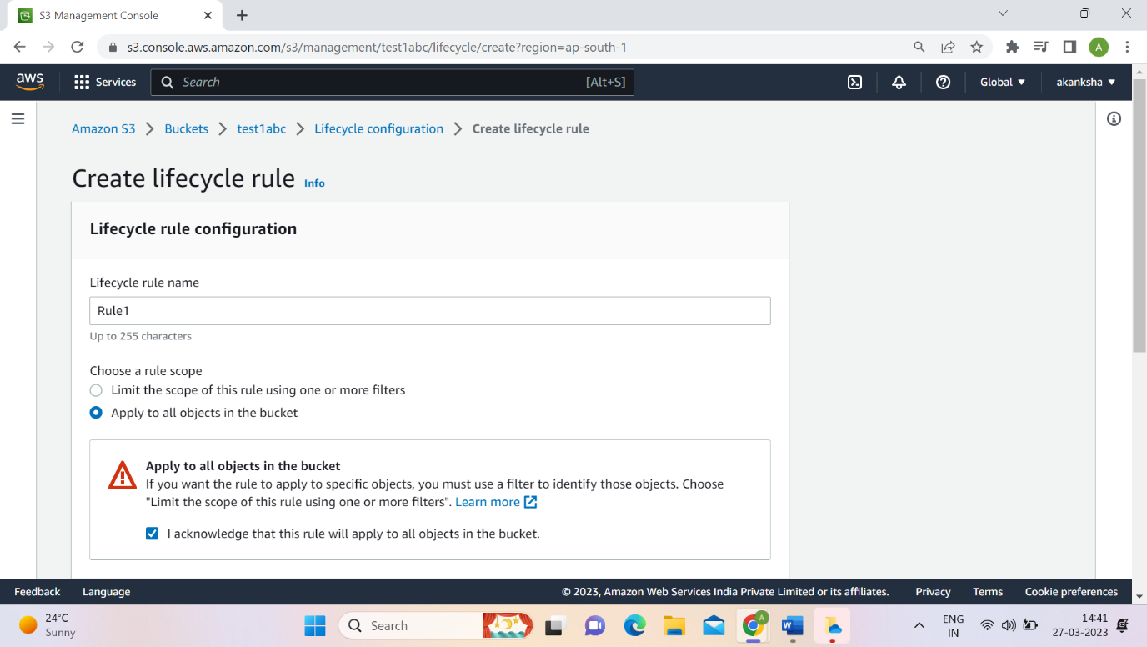

**Step 46:** Select the actions to delete the replicated object after specific time. Give the time period.

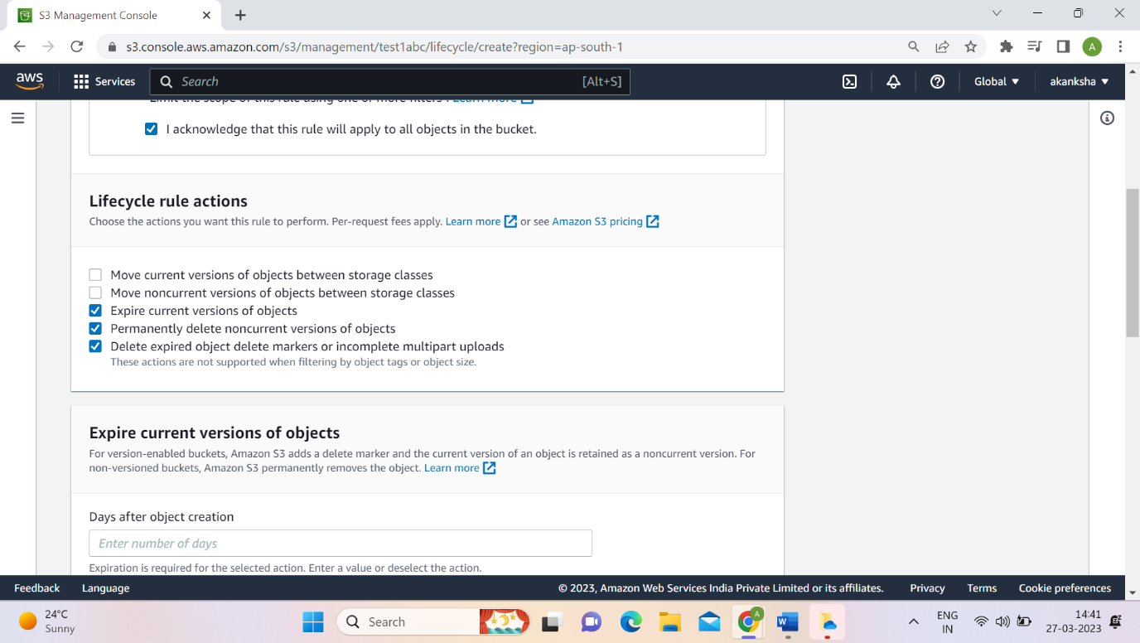

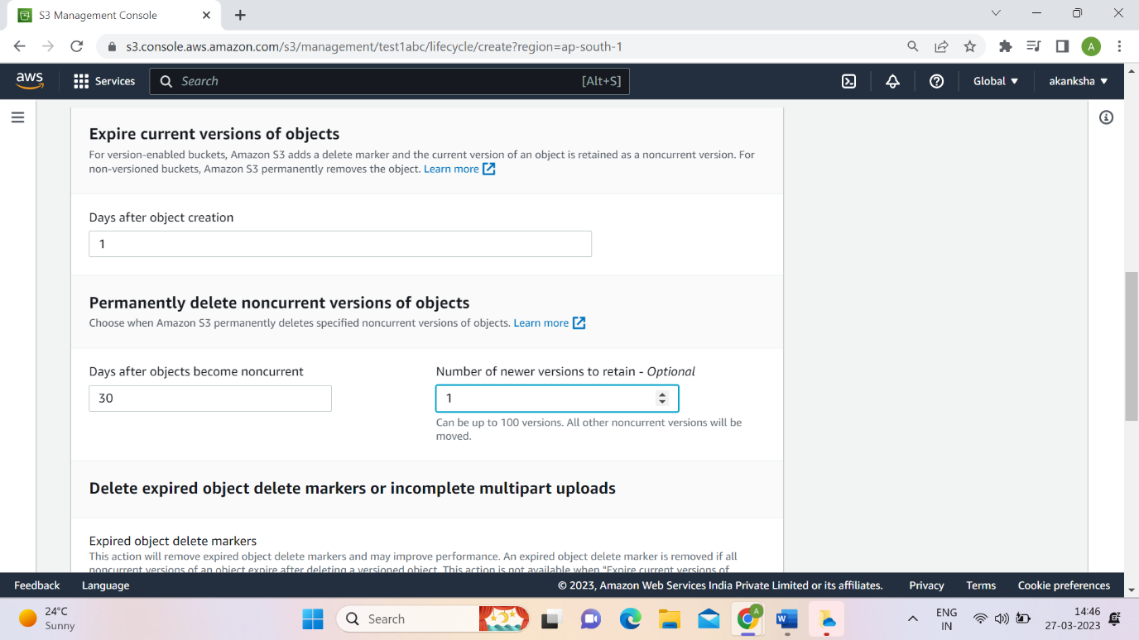

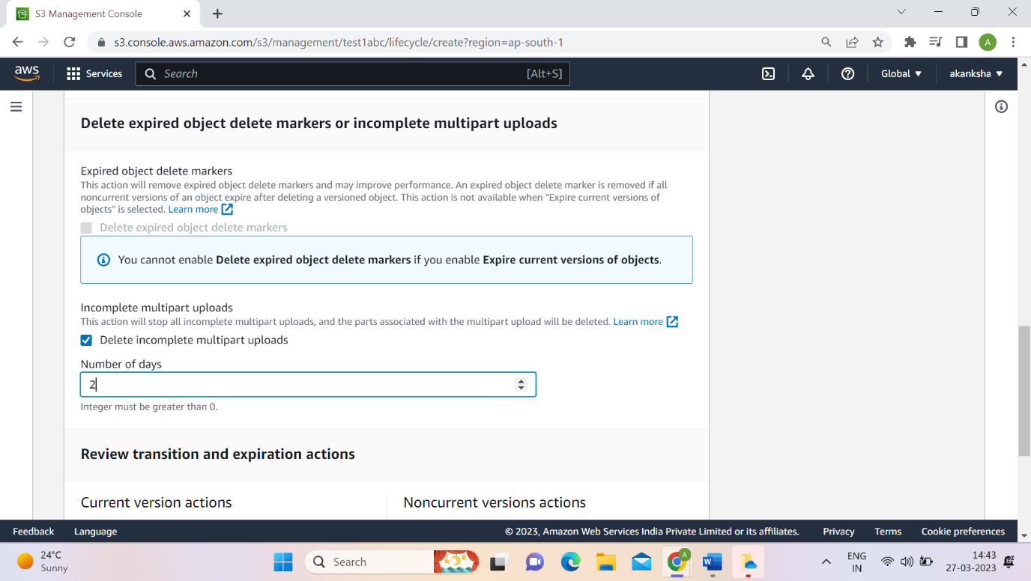

**Step 47:** Click on the create rule option. Then rule will be applied on the replicated buckets.

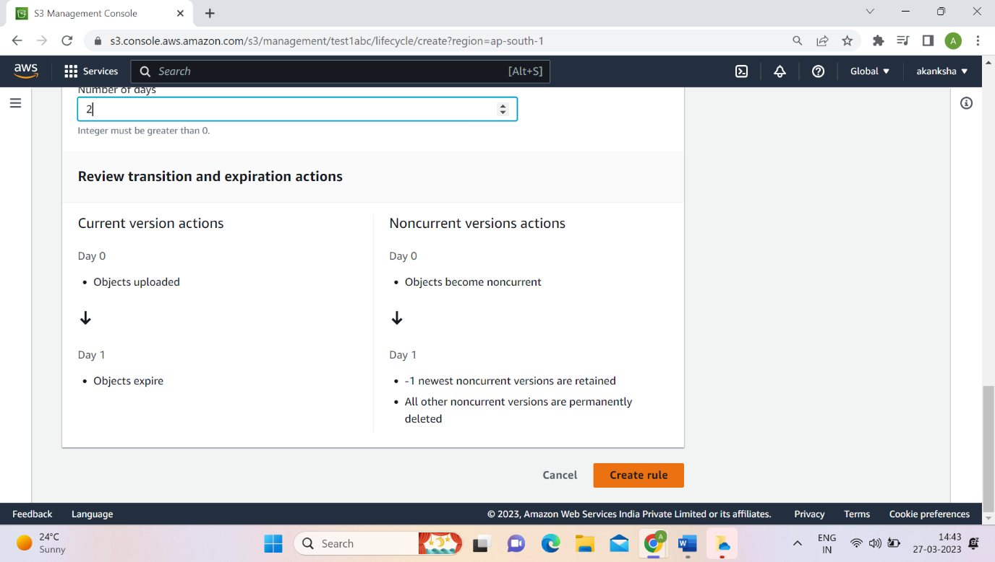

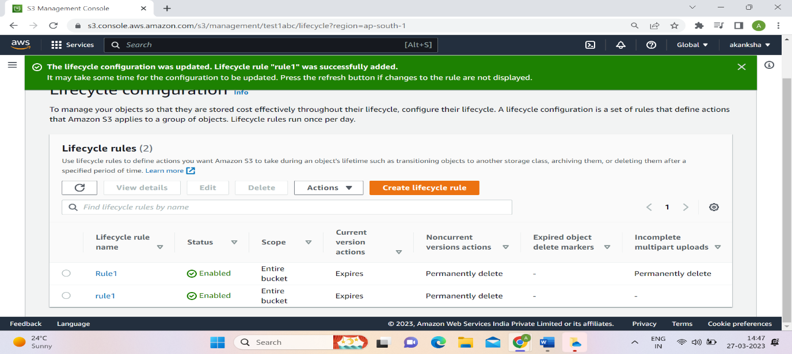

**Step 48:** Click on ‘test1abc’.

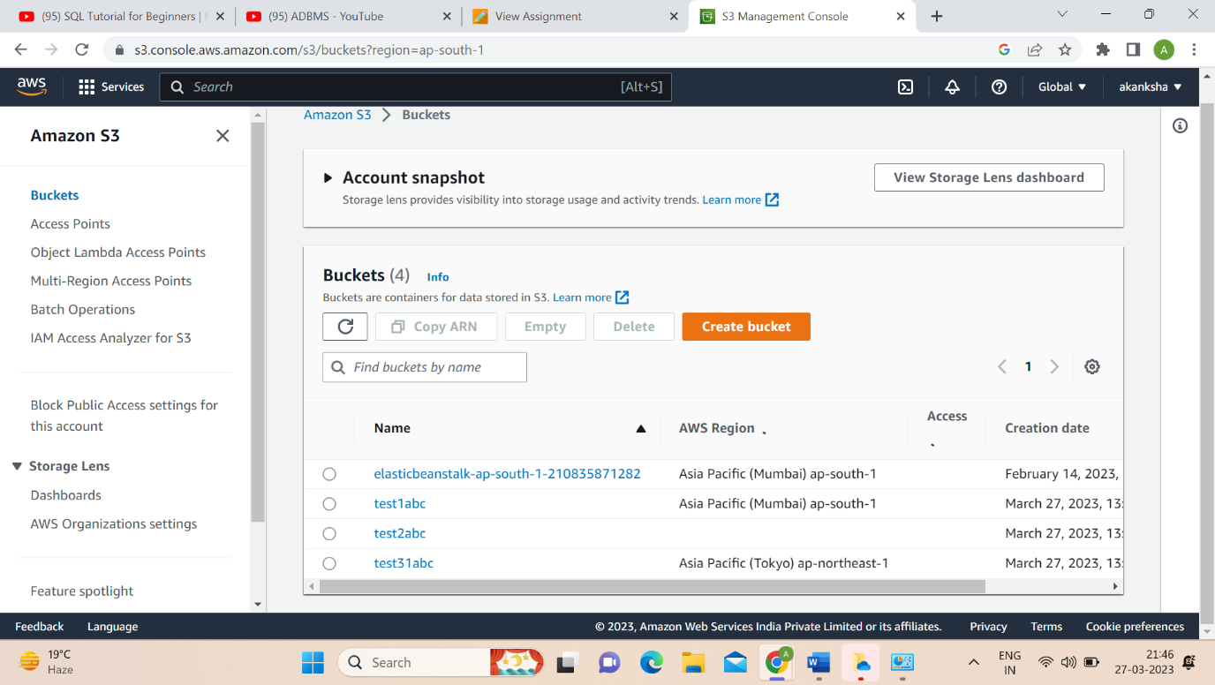

**Step 49:** Go on management and click on create lifecycle rule.

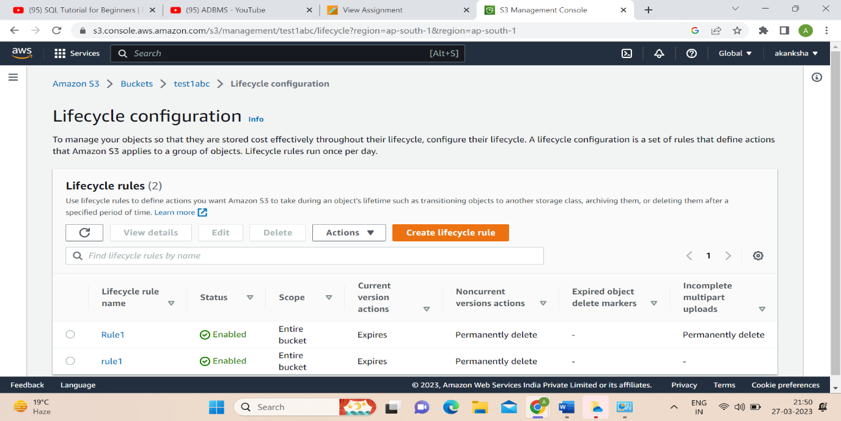

**Step 50:** Give name of rule. Select apply to all objects in the bucket option and acknowledge it.

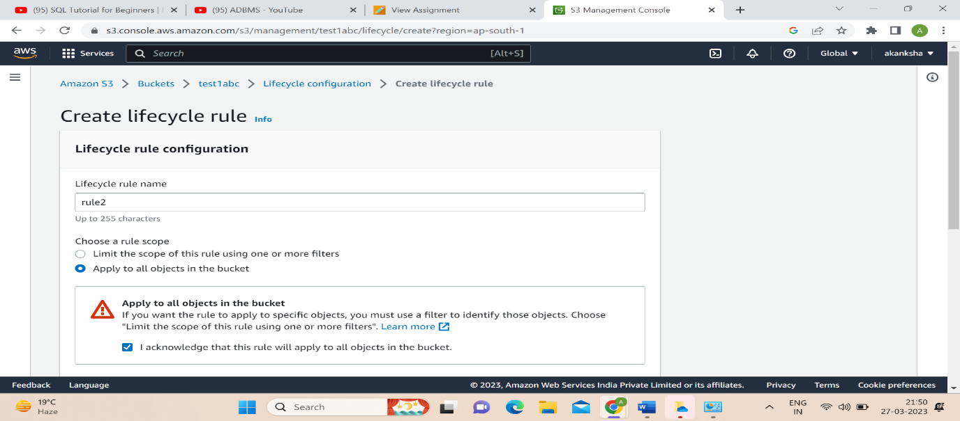

**Step 51:** Add actions. Add days of object creation days for transition current and non-current option.

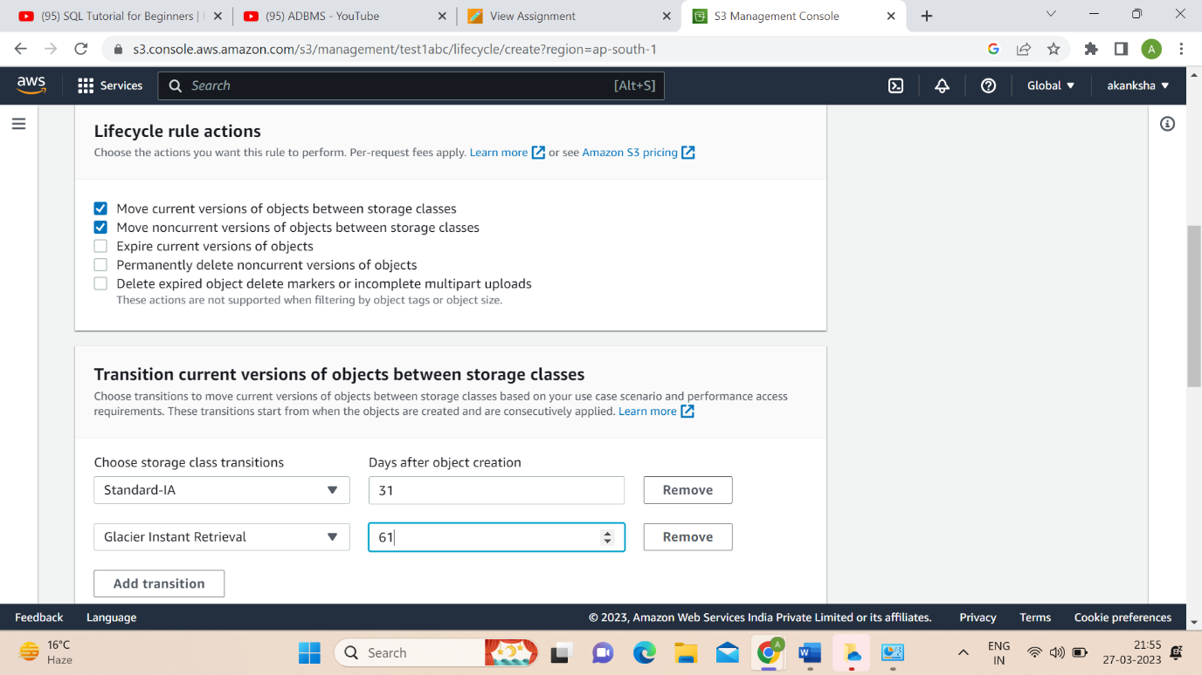 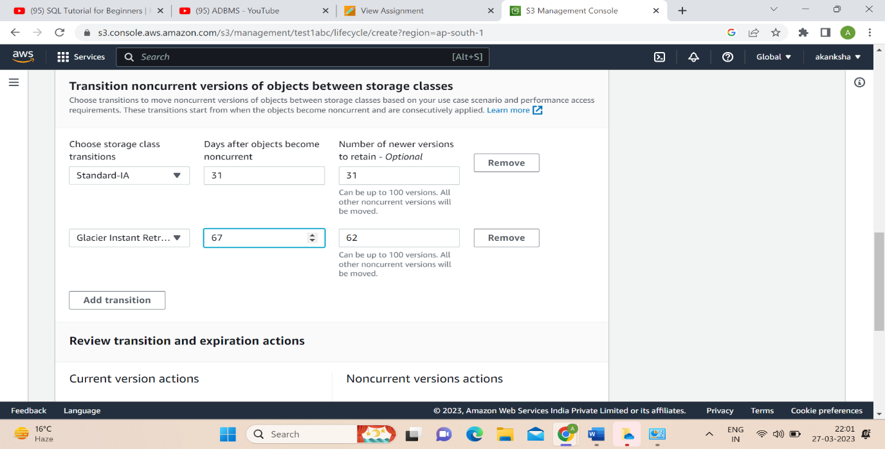

**Step 52:** Click on create rule.

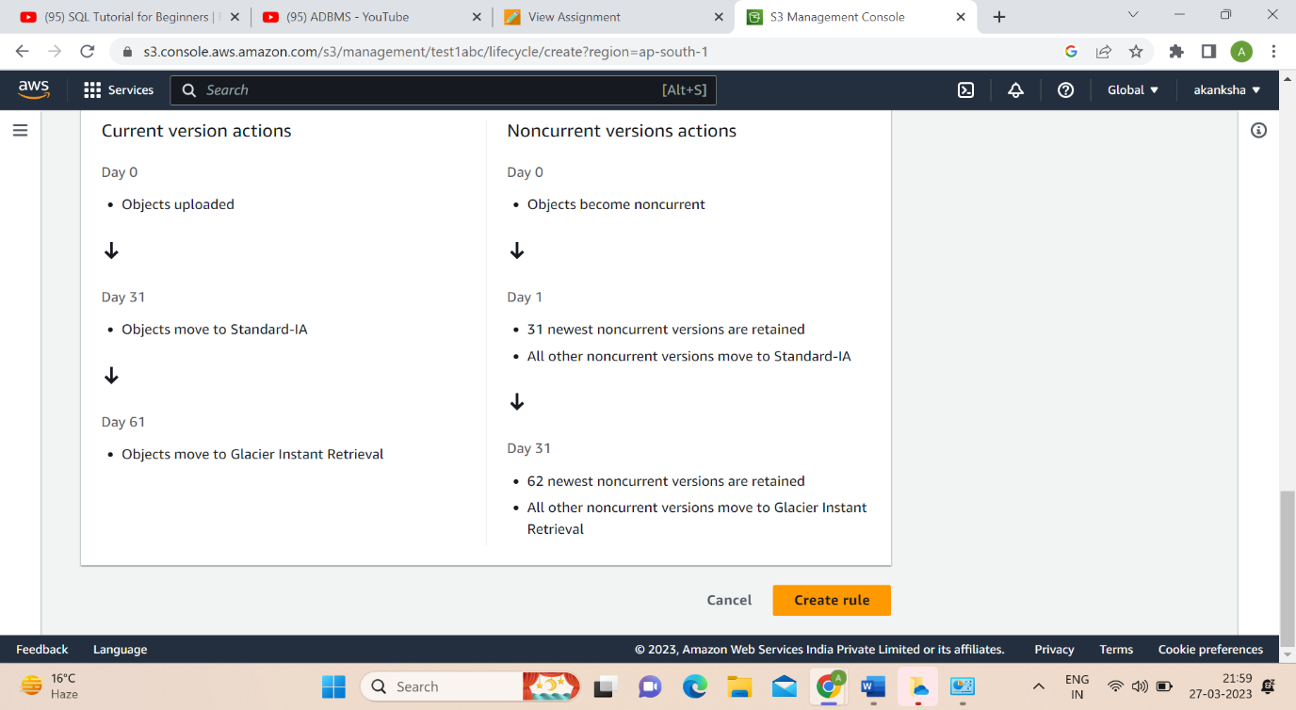

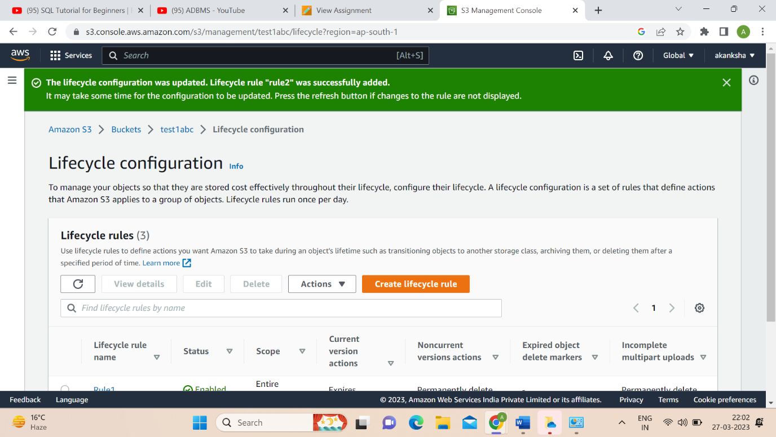

**QUESTIONS**

**Ques1:** Why we have different storage classes in S3 and explain these in detail.

**Ans:** Amazon S3 provides different storage classes to help customer optimize costs and performance based on their specific use case and requirements. Amazon S3 provides a range of storage classes to meet different needs in terms of cost, durability, availability, and performance. By choosing the appropriate storage class, customer can optimize costs and ensure that data is stored in the most appropriate way for use case. The following are the different storage classes in S3:

1. S3 Standard: - S3 Standard is the default storage class, which is designed for frequently accessed data. It provides high durability, availability, and performance. S3 Standard is ideal for use cases such as big data analytics, mobile and gaming applications, content distribution, and backups.
2. S3 Intelligent: - Tiering S3 Intelligent-Tiering is designed to automatically move data between two access tiers based on changing access patterns. It provides the same durability, availability, and performance as S3 Standard, but at a lower cost.
3. S3 Intelligent: - Tiering is ideal for use cases where data access patterns are unknown or unpredictable.
4. S3 Standard: - Infrequent Access (S3 Standard-IA) S3 Standard-IA is designed for data that is accessed less frequently but still requires fast access when needed. It provides lower storage costs compared to S3 Standard, but with a retrieval fee for accessing the data. S3 Standard-IA is ideal for use cases such as backups, disaster recovery, and long-term storage.
5. S3 One Zone-Infrequent Access (S3 One Zone-IA): - S3 One Zone-IA is similar to S3 Standard-IA but stores data in a single availability zone instead of replicating it across multiple zones. This makes it less durable than S3 Standard-IA, but it is cheaper and suitable for data that can be easily recreated in case of a zone-level outage.
6. S3 Glacier: - S3 Glacier is designed for long-term data archival and provides very low storage costs but with a longer retrieval time than S3 Standard and S3 Standard-IA. S3 Glacier is ideal for use cases such as regulatory compliance, legal, and financial data retention.
7. S3 Glacier Deep Archive: - S3 Glacier Deep Archive is designed for long-term data archival with the lowest storage costs, but with the longest retrieval time among all S3 storage classes. S3 Glacier Deep Archive is ideal for use cases such as digital preservation, scientific research, and healthcare records retention.

**Ques 2:** What do you understand by lifecycle management in S3.

**Ans:** Lifecycle management in Amazon S3 is a feature that allows customer to automatically manage the lifecycle of objects stored in S3 buckets. With lifecycle management, customer can define rules that transition objects to different storage classes or delete them based on their age or other criteria. Lifecycle management can help them to optimize costs by moving less frequently accessed data to lower-cost storage classes, such as S3 Standard-Infrequent Access (S3 Standard-IA) or S3 Glacier. Customer can also use lifecycle policies to delete objects that are no longer needed, such as expired user data or old backups. To set up lifecycle management, they define lifecycle policies that are applied to objects in a specific S3 bucket. A lifecycle policy consists of one or more rules that define the transitions and actions to be taken on objects that match specific criteria. For example, they can define a rule that transitions objects to the S3 Standard-IA storage class after 30 days of creation, and another rule that deletes objects after 90 days. Lifecycle policies can be applied to all objects in a bucket or to objects with specific prefixes or tags. Customer can also use versioning to apply lifecycle policies to specific versions of objects.

**Ques 3:** What do you understand by replication rules in S3.

**Ans:** Replication rules in Amazon S3 allow us to automatically replicate objects from one S3 bucket to another. This feature is commonly used for data backup, disaster recovery, and to ensure high availability of data across different regions. With replication rules, we can define which objects to replicate, the destination bucket, and the storage class of the replicated objects. We can also configure replication rules to replicate all object metadata, including object ACLs and object tags. Replication rules can be set up for the entire bucket or for specific prefixes or tags. We can also use filters to control which objects are replicated based on specific criteria, such as object size, modification time, or object prefix. S3 replication rules are a powerful feature that can help us ensure the availability, durability, and compliance of our data. By replicating data to multiple regions, we can reduce the risk of data loss or downtime and improve the performance of our applications.